

User Guide
Using the Dot Pad 320 With Dot Canvas

Dot Incorporation

08507
146, Gasan Digital 1-ro, Geumcheon-gu, Seoul, Korea
Room 403 (Daeryung Techno Town 22nd)
Phone Number: +82) 2-864-1113
Fax: +82) 2-864-1989
Email: inquiry@dotincorp.com
Homepage: www.dotincorp.com

Table of Contents
Table of Contents 2
1. Introduction 3
1.1. Introduction to Dot Canvas 3
1.2. System Requirements 3
2. Using Dot Canvas App 3
2.1. Introduction to Dot Canvas App 3
2.2. Starting Dot Canvas App 4
2.2.1. Downloading Dot Canvas App 4
2.2.2. Creating an Account 4
2.2.3. Logging In 4
2.2.4. Finding Forgotten Username/Password 4
2.2.5. Screen Layout of Dot Canvas App 4
2.3. Connecting Dot Canvas App with the Dot Pad 320 5
2.3.1. Troubleshooting Connection Issues 5
2.3.2. Disconnecting the Dot Pad 320 5
2.4. Using Dot Canvas App Features 6
2.4.1. Create Canvas 6
2.4.2. My Drawings 8
2.4.3. Dot Cloud 8
2.4.4. Settings 8
2.4.5. Using the Dot Pad 320 buttons in Dot Canvas App 9
3. Using Dot Canvas Web 11
3.1. Introducing Dot Canvas Web 11
3.1.1. Screen Layout of Dot Canvas Web 11
3.2. Starting Dot Canvas Web 11
3.3. Connecting Dot Canvas Web to Dot Pad 320 11
3.3.1. Troubleshooting Connection Issues 12
3.3.2. Disconnecting the Dot Pad 320 12
3.4. Using Dot Canvas Web Features 12
3.4.1. Create Canvas 12
3.4.2. Dot Cloud 15
3.5. Updating Firmware Through Dot Support 16

Introduction

Introduction to Dot Canvas
Dot Canvas is a versatile digital tool designed for the Dot Pad 320, offering both an app and a web-based platform to create, edit, save and share tactile graphics and braille text. Tailored to the needs of visually impaired and blind users, Dot Canvas enables the creation of rich, multi-sensory content, empowering users to design and interact with tactile information in ways that enhance learning, creativity, and accessibility.
It provides a comprehensive solution for creating and managing tactile content, making it an essential tool for users seeking to leverage the full capabilities of the Dot Pad 320 in various contexts, from education and professional use to personal projects.

System Requirements
Dot Canvas APP
- Operating Systems: iOS/iPadOS
- Download: Available on the Apple app store by searching for ‘Dot Canvas’.
※ For Optimal drawing experience, using the app with an iPad is recommended.
Dot Canvas Web
- Hardware Requirements: PC with Bluetooth support
※ Dot Canvas Web is optimized for use with the Chrome browser

Using Dot Canvas App

Introduction to Dot Canvas App
Dot Canvas App is an iPhone/ iPad application that can be used in connection with the Dot Pad 320, enabling users to create and display tactile information such as dots, lines, shapes, images, and text.
It empowers visually impaired and blind users to design and modify their own tactile graphic content. Users can simply save the content to “My Drawing”, “Personal Drive”, or share them on the “Public Drive”. The tactile graphics, whether saved or shared, can be easily accessed and displayed on the connected Dot Pad 320.

Starting Dot Canvas App

Downloading Dot Canvas App
Search for “Dot Canvas” in the Apple App Store and download it
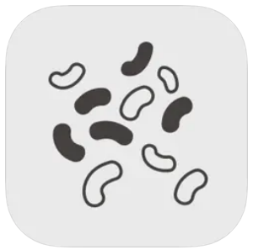 Dot Canvas App
※ Dot Canvas App is an application developed by Dot Incorporation

Creating an Account
Dot Canvas is provided as an app and a website. Users can create one account to access both versions and experience the same tactile graphic content saved in their Personal Drive. Account registration is available through both the app and the website. Account registration method through the Dot Canvas App is as follows:
- After launching Dot Canvas App, select the [Create Account] button.
- When the “Create A New Account” page comes up, fill in the required information.
- Enter the verification code issued through the email you entered.
- Complete account registration after entering the required additional information.

Logging In
After completing the account registration, you can log in to Dot Canvas App by entering your registered username and password.
- When Dot Canvas App is launched, the login screen appears, and the username input window is focused.
- Enter your username and password you created and select the Login button to move to the main screen.
※ If you enter your username and password and select the Remember ID button, the entered username information is maintained when you log in again.

Finding Forgotten Username/Password
In case you lose your username or password, you can reset your password in the following steps:
- If you lose your username, select the [Forgot Username?] button and enter the name and registered email address.
- If you lose your password, select the [Forgot Password?] button and enter your username.
- Check the verification code sent to the registered email and enter it.
- Check the username or reset your password with a new one.

Screen Layout of Dot Canvas App
The main screen of Dot Canvas App consists of the following sections:
- Create Canvas
- Create and edit the tactile graphic content using various drawing tools.
- As your draw on Dot Canvas App, the content is automatically displayed in real-time on the Dot Pad 320.
- My Drawing
- Save the content you create directly onto your device.
- Content saved in “My Drawing” can be printed on the Dot Pad 320 without requiring an internet connection.
- Dot Cloud
- Dot Cloud is a cloud storage service where you can save and access your content in an Internet-connected environment.
- You can save the content you create in your Personal Drive or share them in the Public Drive.
- Settings
- Connect or disconnect from the Dot Pad 320.
- Select the braille language to be displayed on 20 cells of the Dot Pad 320
- Profile
- View the user's registered name and username.
- Log out of Dot Canvas App.

Connecting Dot Canvas App with the Dot Pad 320
After logging in to Dot Canvas App, it will be directed to the main screen. Users can connect Dot Canvas App to the Dot Pad 320 via Bluetooth. To connect the Dot Pad 320, please follow the steps below:
- From the main screen, go to [Setting] > [Connect]
- Select the Dot Pad 320 Bluetooth number you wish to connect to.
- When the connection is successful, the Dot Pad 320 will vibrate twice.

Troubleshooting Connection Issues
If the Dot Pad 320 you wish to connect to does not appear in the connection list, please check 3 things below:

- Make sure the Dot Pad 320 is turned on.
: If the Dot Pad 320 is turned off, turn it on and select the [Refresh] button in the connection list.
- Make sure the device’s Bluetooth running Dot Canva App is turned on.
: If the device’s Bluetooth is turned off, please turn it on and select the [Refresh] button in the connection list.
- Check whether VoiceOver is paired with the Dot Pad 320.
: If the Dot Pad 320 is paired with VoiceOver braille display, please disconnect the Dot Pad 320 with VoiceOver braille display in the following order.
- Apple [Settings] > [Accessibility] > [VoiceOver] > [Braille]
※ You can go to [Settings] > [Accessibility] > [VoiceOver] by selecting the Apple Settings button in the pop-up window.
- Focus the connected Dot Pad 320 at the bottom of the screen and swipe up to go to More Information.
- Select [Forget this Device] to disconnect the Dot Pad 320.

Disconnecting the Dot Pad 320
To disconnect the currently connected Dot Pad 320, please follow the steps below:
- From the main screen of Dot Canvas APP, navigate to [Setting]
- Select the [Connect] button
- The disconnection will be confirmed by the Dot Pad 320 vibrating twice.

Using Dot Canvas App Features

Create Canvas
Using various drawing tools, users can freely create pictures by drawing shapes and add textual descriptions for the picture. The graphics created through Dot Canvas App are displayed on the 300-cell part of the Dot Pad 320 in the form of tactile graphics, and the text descriptions are displayed in braille on the 20-cell part of the Dot Pad 320.

The layout of the Create Canvas screen is as follows:

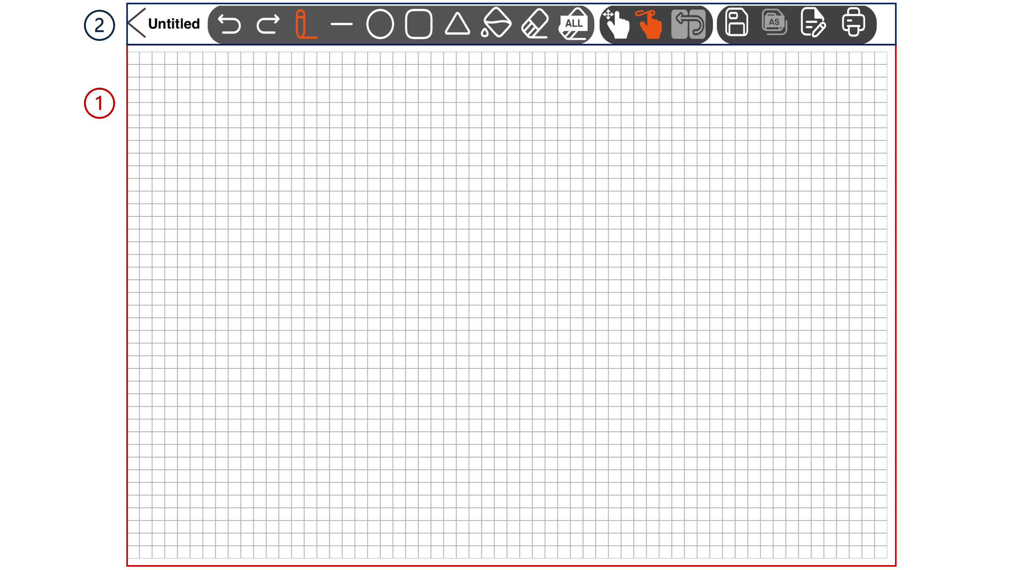
- Canvas: Occupying the largest area of the screen, the canvas is where users can draw tactile content by touch.
- Drawing Menu Bar: Located at the top of the screen, it is a collection of various drawing tools that can be used for creating and modifying tactile content.

Table 1 Dot Canvas App Drawing Tools
 | Back  Exit the Canvas Creation screen and return to the main screen.  If you press the Back button while creating tactile graphics, a warning window will prompt you to save your progress. Choosing [No] closes the window, while selecting [Save] allows you to name the file and choose a save location. The file will be saved in either My Drawings or Dot Drive, based on your selection. | 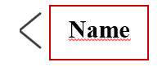 | File Name  File name you are working on.
 | Undo/Redo  Undo or redo the latest work. |  | Pen  Draw freely, just as you draw with a pen.
 | Line  Select and adjust th.3e desired length with one finger on the screen to draw a line. |  | Square/Rectangle  Select and adjust the desired size with one finger on the screen to draw a square or rectangle.
 | Circle  Select and adjust the desired size with one finger on the screen to draw a circle. |  | Triangle  Select and adjust the desired size with one finger on the screen to draw a right triangle.
 | Fill  Fill an area made up of lines to be blacked out with dots. |  | Erase  Erase the area you want to clear.
 | Clear All  Erase all the paintings on the canvas at once. |  | Save  Save your work by pressing the Save button, which opens a pop-up to choose a storage location. The file will be saved in My Drawings or Dot Drive after you select the location and enter a file name.
 | Canvas Navigation Mode  This mode allows users to explore the position of their fingers on the screen before starting to draw. |  | Drawing Mode  This mode allows users to draw on the canvas.
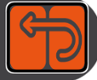 | Menu Navigation Mode  This mode is used to navigate and select drawing tools in the Dot Canvas app. |  | Save As  If you modify an existing saved file, you can change the file name and save it.
 | Pages  • Displays a pop-up where you can create or delete a page and add a page description.  • The bottom of the pop-up shows arrow buttons and current page details for navigation.  • When inserting page description, it is automatically saved and translated into 20-cell display of the Dot Pad 320 after the pop-up is closed. |  | Print  Print the picture you worked on to Dot Pad 320.

My Drawings
Dot Canvas App enables users to create or modify tactile graphic content and save it to their device’s internal storage. In the "My Drawing" section, users can view a list of files stored internally. If many files are saved, the search bar allows users to quickly locate specific files by entering the file name. Each file contains the file name and the date it was created.

When selecting the file name, a context menu is displayed, and the first picture of the file is displayed on the Dot Pad 320. The components of the context menu are as follows:
- Open: Run the selected file. When the file runs, the picture on the first page and the description of the picture are displayed on the Dot Pad 320. Users can go to the previous/next page and modify the picture and description by clicking the [Edit] button.
- Delete: Deletes the selected file.
- Rename: Modify the saved file name.
- Exit: Exit the context menu.

Dot Cloud
Users can save their personal content and open various public content through the Dot cloud, a cloud-based tactile graphic content online storage service provided by Dot Inc.

- Personal Drive
  - Users can upload tactile graphic content created in Dot Canvas App to their Personal Drive. This cloud-based personal storage allows access to content across multiple devices without restrictions.
- Public Drive
  - Users can explore various shared tactile graphic content organized by themes, and also share their own drawings to the Public Drive for others to access.

Settings
Set up the Dot Pad 320 connection or select a braille language supported by Dot Canvas App
- Connect or Disconnect Dot Canvas App with the Dot Pad 320
- Select the braille language
- Select the braille language to be displayed on the 20-cell display of the Dot Pad 320.
- Braille language must be in correspondence with input language.
- The 23 braille languages currently supported by Dot Canvas App are as follows:
Korean, English, Chinese, Japanese, Vietnamese, Thai, Arabic, French, Italian, Spanish, Catalan, German, Czech, Polish, Norwegian, Russian, Portuguese, Danish, Greek, Swedish, Finnish, Kazakh, Khmer.

Using the Dot Pad 320 buttons in Dot Canvas App

- Navigating the 20-cell text display on the Dot Pad 320
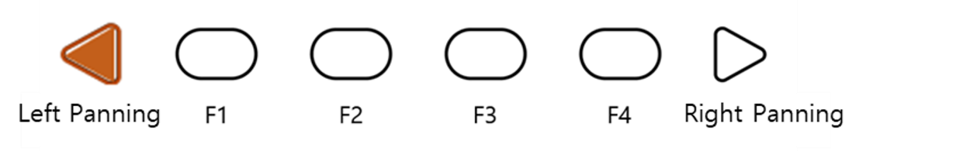
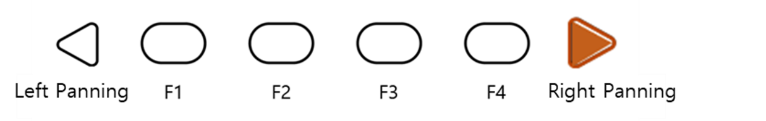
- If the content in the 20-cell text area becomes lengthy, users can navigate through the content using the panning key buttons.
- Right panning key button: Move to the next line (20 cells)
- Left panning key button: Move to the previous line (20 cells)

- Navigating the 300-cell graphic and multi-line display on the Dot Pad 320
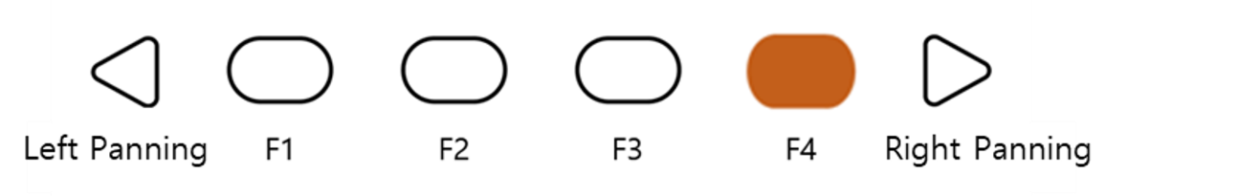
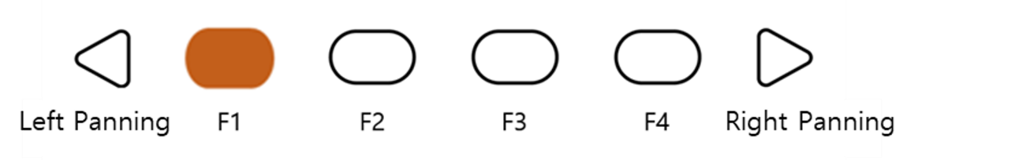
- If the content in the 300-cell graphic/multiline area becomes lengthy, users can navigate through the content using the F1 and F4 buttons.
- F4 button: Move to the next page (300 cells)
- F1 button: Move to the previous page (300 cells)

- Dot Pad 320 Shortcut buttons for drawing tools
When connecting the Dot Pad 320 to the Dot Canvas app, users can easily use various functions by using the Dot Pad 320 buttons.

- Select Pen Tool
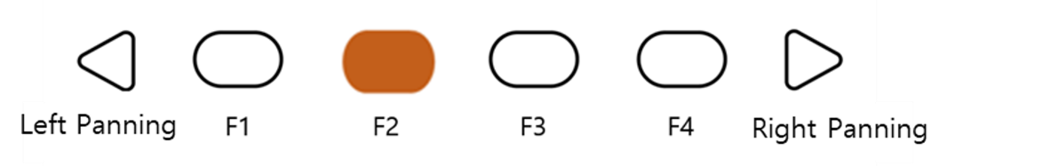
In the Create Canvas page, pressing the F2 button will select the 'Pen Tool' among the drawing tools.

- Erase All
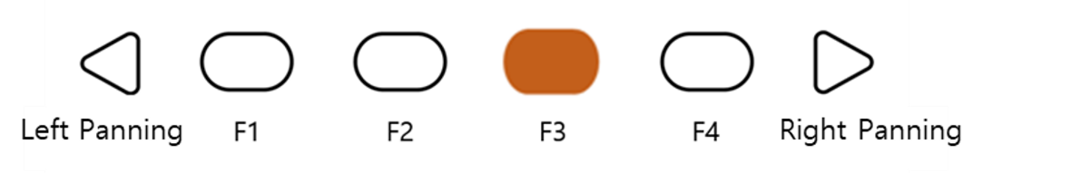
Users can erase all their drawings on the current page with the F3 button. It shortens the time and simplifies clearing the drawing with a single click of the button.

- Add a New Page
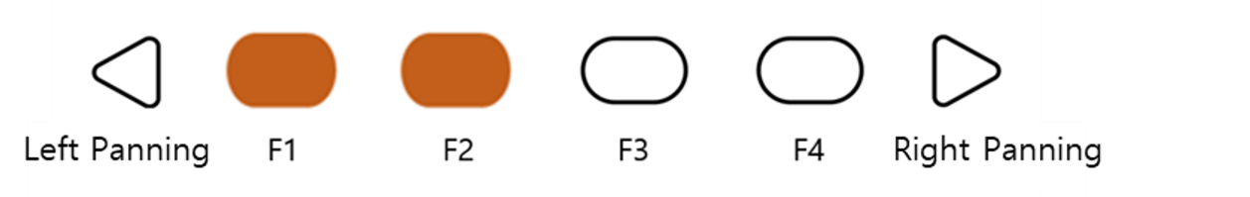
Users can press F1 and F2 together to add a new page to the canvas. Users can move to the next page by pressing the F1 and F4 buttons.

- Delete Current Page
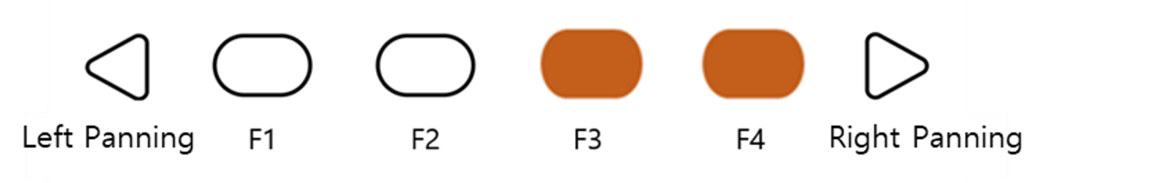
Users can delete their current canvas by pressing the F3 and F4 button together. After deleting the page, users can move pages with buttons F1 and F4.

- Changing Canvas Mode
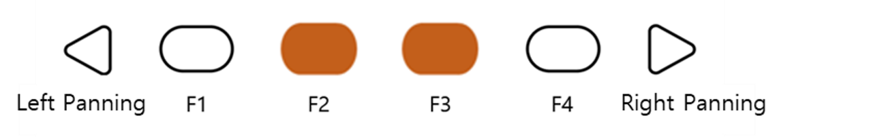
As a user-friendly application, Dot Canvas provides a mode that allows visually impaired users to draw and use the tools easily. Users can press F2 and F3 together to change the mode.

※ Types of Canvas Mode

- Canvas Navigating Mode
: Before drawing on the iPad, users can identify the position of their finger.
If they touch the iPad screen in navigating mode, the Dot Pad 320 will display the
Position of the finger with a crosshair cursor. When the finger stops at a certain
position, the cursor will start to blink.

- Draw Mode
: After deciding their position to start the drawing with the navigating mode, users can start drawing with draw mode by pressing F2 and F3 at the same time.

- Menu Navigation Mode
: In Menu Navigation Mode, users can pan around the drawing tool menu located on the top of the canvas. When the mode is at menu navigation mode, the canvas becomes deactivated, and the users will not be able to draw on the canvas even when they tap the canvas area.

Using Dot Canvas Web

Introducing Dot Canvas Web
Dot Canvas Web is a web version of tactile graphic creating tool optimized for the Dot Pad 320 where users can create, save, and share digital tactile graphics. With user-friendly tools, anyone can effortlessly create, edit, and save their own tactile content, and use this content to their tailored needs, whether for education, creative projects, or other applications.
Users can upload image files onto Dot Canvas Web to convert it into tactile graphics automatically. With Dot’s braille translator, it is possible to print braille from texts on the Dot Pad 320 in real time. Dot Canvas Web allows multiple units of Dot Pad 320 to be connected and displayed at once.
※ Dot Canvas Web is available only with PC that supports Bluetooth.

Screen Layout of Dot Canvas Web
The screen layout of Dot Canvas Web is as follows.
- Dot Canvas
- Create or edit tactile graphics using various drawing/editing tools.
- Print the content that you have created onto the Dot Pad 320.
- Dot Cloud
- Upload and save the tactile graphic that you have created onto your Personal Drive.
- You can share your Personal Drive content to the Public Drive. In the Public Drive, you can access, edit shared content by others and save it to your Personal Drive.
- Print the content uploaded from your Personal Drive and Public Drive onto the Dot Pad 320.
- Dot Support
- Update the firmware of your Dot Pad 320 to the latest version.
- Submit an inquiry or leave feedback.

Starting Dot Canvas Web
- Go to apps-dotincorp.com.
- Create an account by signing up and log into Dot Canvas Web.
※ Dot Canvas (Web) and Dot Canvas (App) share the same account
※ Chrome is the recommended browser.
- If you have forgotten your username or your password, use the e-mail address code verification method to find your username or reset your password.

Connecting Dot Canvas Web to Dot Pad 320
To connect the Dot Pad 320 to Dot Canvas Web, follow these steps:
- Open Dot Canvas and click the [Dot Pad] icon located at the top-right corner of the screen.
- Click [Search Device] to search for nearby Dot Pad 320 devices.
- Select your desired Dot Pad 320 from the list and click [Pair] at the bottom.
- If you wish to connect multiple devices, repeat the steps.

When the Dot Pad 320 is successfully connected, the Dot Pad 320 vibrates twice.

Troubleshooting Connection Issues
If the Dot Pad 320 that you want to connect is not in the list of available devices, please check the following.
- Check the power status of the Dot Pad 320:
- If the power of the Dot Pad 320 is turned off, turn it on and click [Search].
- Check the Bluetooth status of the PC:
- If the Bluetooth of the device is turned off, turn Bluetooth on and click [Search].
- Check if the Dot Pad 320 is connected to iOS VoiceOver. If paired with VoiceOver, follow the steps below and unpair the device:
- Apple [Settings] > [Accessibility] > [VoiceOver] > [Braille]
- Scroll all the way down and select the Dot Pad 320 that is connected and go to [More Information]
- Click [Forget this Device] and unpair the Dot Pad 320.

Disconnecting the Dot Pad 320
Go into the Dot Pad 320 Connect pop-up screen and select [Disconnect]. The Dot Pad 320 will be disconnected with two long vibrations.

Using Dot Canvas Web Features

Create Canvas
Use various drawing/editing tools to create any shapes and images freely and insert multiline Braille text. Dot Canvas screen layout is as follows:

- Top Right
- Profile Button: Users can check the account’s profile, connect/disconnect the Dot Pad 320, and log in/out of the account.
- Language Button: Users can select the default language as Korean or English.
- File Management Menu:
- New: New canvas is created for the user to create new drawings.
- Open: Users can open the content from their Personal Drive or Public Drive.
- Add: Users can add tactile image files that are in a DTMs format.
※ DTMs is a file format that the Dot Pad 320 supports.
- Export: Users can save the currently created canvas as a DTMs file.
- Save: Users can save the current canvas onto the Dot Drive.
- Save As: Users can save the current canvas onto the Dot Drive with a different file name.
- File Name: The current file name of the canvas will be shown. If there is no file name, it will be shown as “Untitled.”
- Drawing/Editing Menu
- It is located on the left side of the Dot Canvas Web screen.
- It is used to create or edit tactile graphics on the canvas.
- Drawing/Editing Menu are as follows:

Table 2 Dot Canvas Web Drawing Tools
 | Undo/Redo  Undo or redo the latest work |  | Pen Size  Choose the thickness of the pen
 | Pen  Draw freely | 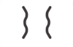 | Vertical Mirror Pen  Draw a symmetrical image
 | Move  Recognize and move images on the current page as one object |  | Paint Bucket  • Fill in the selected area  • Used for closed shapes and lines
 | Erase  • Delete the area you want to modify  • The size of the eraser is proportional to that of the pen. |  | Clear  Delete everything from the current page
 | Line  • Draw straight lines, diagonal lines, etc.  • Press [Shift] while drawing with this tool to create a straight line |  | Square/Rectangle  • Draw squares/rectangles  • Press [Shift] and drag to create a square
 | Circle  • Draw circles/ovals  • Press [Shift] and drag to create a perfect circle |  | Triangle  • Draw triangles, right triangles, etc.  • Press [Shift] and drag to create an acute triangle
 | Text Box  Creates a text box within the graphic area and translates any text inside into braille |  | Image  • Automatically converts tactile graphics by reading stored image files and setting the minimum and maximum value.  • Click [Insert] to convert the image into tactile graphic onto the canvas
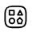 | Templates  A repository that organizes a variety of shapes in one location |  | Multi Braille  Allows users to create multi-line braille by typing or by importing PDF files and converting them into multi-line braille
 | Rectangle Selection  Use shortcut keys to copy, cut and paste, or delete the selected area within the selection |  | Lasso Selection  Use shortcut keys to copy, cut and paste, and delete the selected area within lasso tool
 | Tactile Letters  Converts typed text into tactile graphic representations of the letters

Table 3 Dot Canvas App Drawing Tools Shortcuts
Keys | Edit Tool | Keys | Edit Tool
Top bar
Ctrl+O | Open | Ctrl+S | Save
Ctrl+Shift+S | Save As
Page Description
Alt+P | Print
Multi-Page
Ctrl+G | On/Off Grid
Editing Tool
P | Pen | V | Vertical Mirror Pen
Ctrl | Horizontal Axis  (while using vertical mirror pen) | Shift | Horizontal and vertical axis  (while using vertical mirror pen)
M | Move | B | Paint Bucket
E | Eraser | Ctrl+E | Eraser All
L | Line | R | Rectangle
C | Circle | T | Triangle
X | Text Box | I | Image
S | Rectangle Selection | H | Lasso Selection
Selection
Ctrl + X | Cut Selected Area | Ctrl + C | Copy Selected Area
Ctrl + V | Paste | DEL | Delete Selected Area

- Presentation Mode
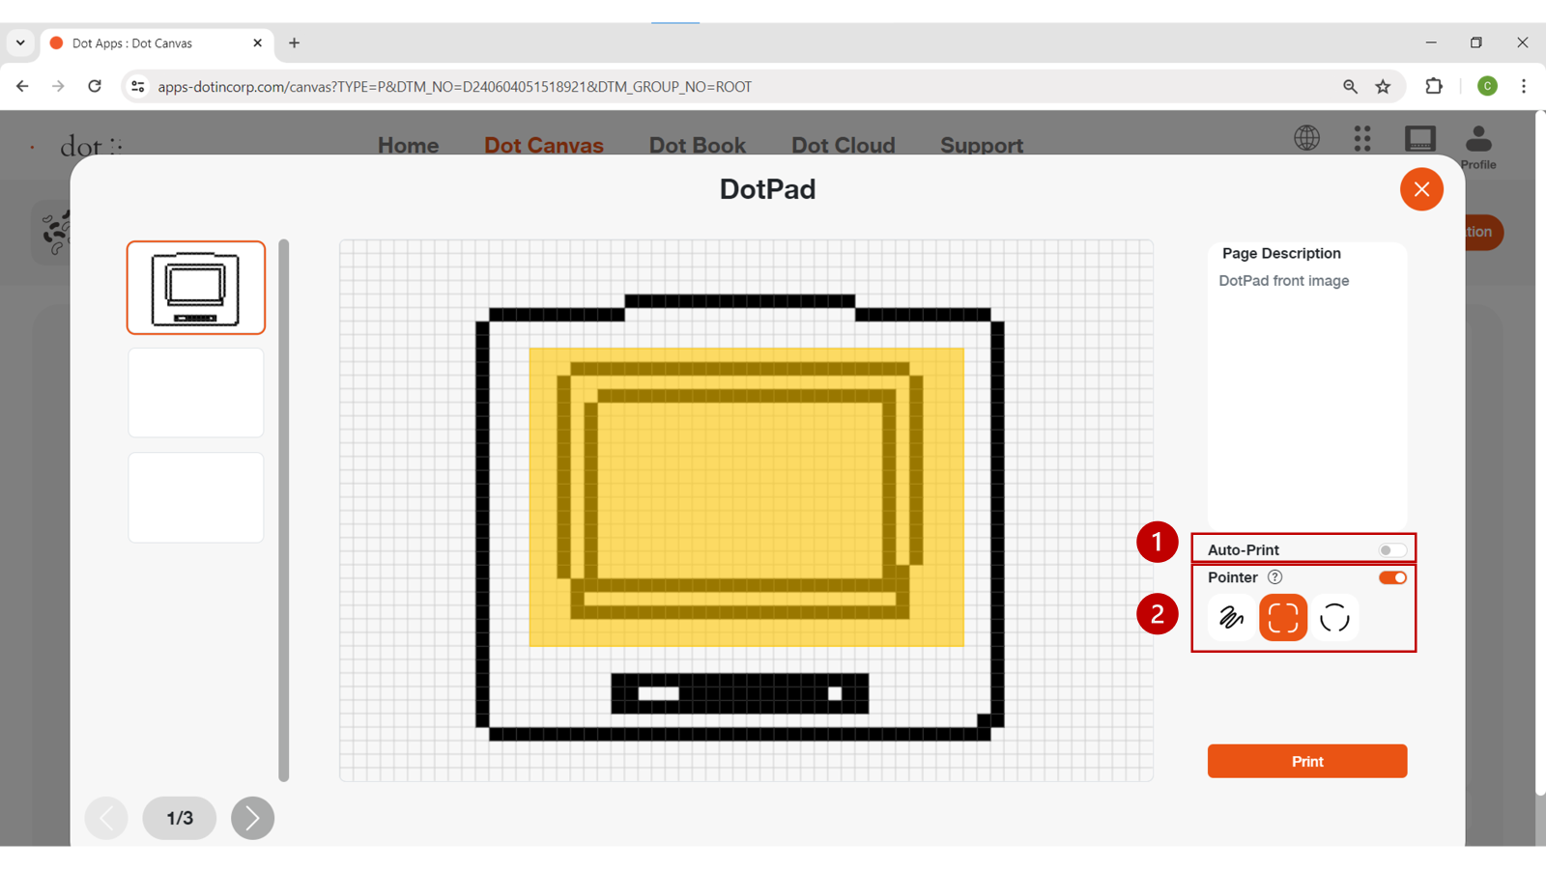
- Presentation Mode offers dynamic learning experience by utilizing Dot Pad and digital tactile graphics in classroom settings.
- Select the Presentation Mode button located in the upper right corner of the Dot Canvas Web screen.
- (1. Auto Print) When DotPad is connected to Dot Canvas Web, users can utilize the auto print feature.
- With the auto print feature enabled, every time users specify an area using the presentation mode pointer, the selected area will automatically be displayed on the DotPad.
- (2. Pointer) Highlight a specific area on the current canvas page using the three types of pointers, and the selected area will be displayed on DotPad.

- Multi-Page Management Bar
- This is located on the left side of the canvas. Users can select to show/ hide grid, arrange the order of the pages, delete pages, and add pages.
※ Grid: Users can choose to show the grid on the drawing area using the grid on/off button.
- Up/Down Button: User can rearrange the order of the pages.
- [-] button: User can delete the page.
- Canvas
- The Canvas is a white drawing screen that takes up the biggest part on the screen.
- Users can create new content using the drawing/editing tool or open an existing content from the drive.
- Page Description
- It is located on the right side of the canvas.
- Users can add descriptions to the images they are creating.
- The input description will be translated into braille automatically but will be viewed in the input language while in Dot Canvas.
- Add Voice
- Users can insert an MP3 file into a specific page. When the file is opened in Dot Cloud, the audio information will play along with the corresponding page output.
- Print
- It is located below Page Description.
- Once the user clicks [Print], the image on the canvas and the accompanying description will be printed on the Dot Pad 320.

Dot Cloud
Users can save their created content onto the Dot Drive or share it with other people. Users can also print various tactile graphics onto the Dot Pad 320 that are saved on the Public Drive.

Dot Drive is separated into a Personal Drive and the Public Drive. The Personal Drive is the default selected drive when the user first clicks on [Dot Drive]. The Dot Drive screen layout is as follows:

- Personal Drive ([User’s Name]’s Drive)
- Files saved or folders created on Dot Canvas will be saved here.
- Folders are displayed first before files.
- Users can open files, share, download, rename, copy, cut, paste, or delete by right clicking the file and then selecting the desired option.
- Click [+] to create a new file, new folder, or upload a file. Users can also right click on the empty space in the drive.
- Users can share the files in their Personal Drive to the Public Drive.
※ Right click on the file you want to share and click [Share]. If you edit a shared file, the shared file will be edited as well.
※ The shared file from the personal drive will show the creator’s icon on the thumbnail.
- Public Drive
- Shared folders and files are saved here.
- The shared files can be displayed onto the Dot Pad 320.
- Users can download the shared files onto the computer or open the file to edit them on Dot Canvas.
- Search
- Users can locate folders and files.
- If users type in the search box, files or folders with matching names will be listed.
- Back and Forth Buttons
- If you click the back button, the page will be redirected to the previous directory.
- If you click the forward button, the page will be redirected to the next directory.
- Gallery View Button
- The default mode of the Dot Drive is gallery view mode.
- The list of folders and files are displayed in the form of a gallery where icons are visible.
- List View Button
- The files will be displayed in list mode.

Updating Firmware in Dot Support Page
You can update the firmware of the Dot Pad 320 without logging in to Dot Canvas (Web).
Here's how to update the Dot Pad 320 firmware:
- Go to Dot Canvas Web at apps-dotincorp.com
- Select the Dot Support tab within Dot Canvas Web.
- Connect the Dot Pad 320 to your PC via the USB C port located on the left side of your Dot Pad 320. After connecting, turn on the Dot Pad 320 and press the Connect Device button on the Dot Support page.
※ Ensure the device remains powered on and the cable is securely connected throughout the update process.
- Connect the Dot Pad 320 by selecting one of the wired port options that appears in the pop-up. If a connection failure notice is displayed, turn the Dot Pad 320 off and on again and try again. After connecting, you can check the device information on the Dot Support page and update it to the latest firmware.
- Select the [Update] button at the bottom of the Dot Pad 320 Firmware Version Information to proceed with the firmware update. The update takes about 3 to 5 minutes depending on the Internet speed.
※ If the firmware is in the latest version, an "Already the latest version of firmware" notice will be displayed.

