

User Manual

Dot Pad 320 (DPA 320A)

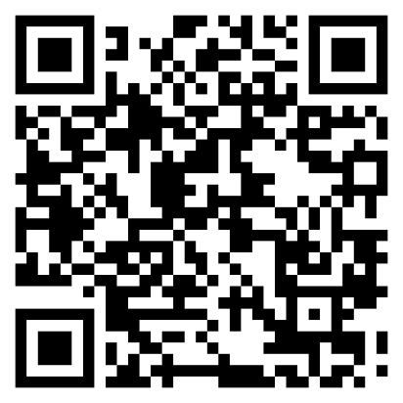

08507
146, Gasan Digital 1-ro, Geumcheon-gu, Seoul, Korea
Room 403 (Daeryung Techno Town 22nd)
Phone Number: +82) 2-864-1113
Fax: +82) 2-864-1989
Email: inquiry@dotincorp.com
Homepage: www.dotincorp.com

Table of Contents
Table of Contents 2
1. About the Dot Pad 320 (DPA320A) 3
1.1. Introduction 3
1.2. What Is the Dot Pad 320? 3
1.3. Dot Pad 320 Appearance 4
1.4. Hardware Specifications 6
1.5. Connectivity 7
2. Basic Functions 8
2.1. Understanding Dot Pad 320 LED Signals 8
2.2. Understanding Device Information Through the Dot Pad 320’s Vibration Signals 8
2.3. Checking the Battery Level 9
2.4. Checking the Charging Status 9
3. Using the Dot Pad 320 9
3.1. Using the Dot Pad 320 with Dot Canvas 9
3.2. Using the Dot Pad 320 with VoiceOver 9
3.3 Using the Dot Pad 320 with NVDA 10
4. Handling and Safety Precautions 10
5. Customer Support 13
6. Product Certifications 13

About the Dot Pad 320 (DPA320A)

1.1. Introduction
Welcome to the Dot Family! We are delighted that you have chosen the Dot Pad 320. This innovative device is designed to provide a rich tactile graphic and multi-line braille experience, enhancing the accessibility of visual information and boosting productivity for visually impaired users. The Dot Pad 320 represents a significant advancement in assistive technology, bringing tactile graphics and braille text together in a single, versatile device.

1.2. What Is the Dot Pad 320?
The Dot Pad 320 is a tactile information display capable of representing both braille text and tactile graphics simultaneously. This functionality allows users to access a wide range of visual content in a tactile format, making it easier to understand and interact with complex information. Additionally, with its multi-line braille, users can experience multiple lines of braille on a single screen, engaging with detailed content more effectively.
As a tactile display, the Dot Pad 320 is compatible with screen readers such as VoiceOver and NVDA. Additionally, it can be connected to software services developed by Dot or third-party developers using Dot's SDK, allowing for versatile usage across various platforms and applications.

1.2.1. Components of the Dot Pad 320
When you purchase a Dot Pad 320, it includes the following components:
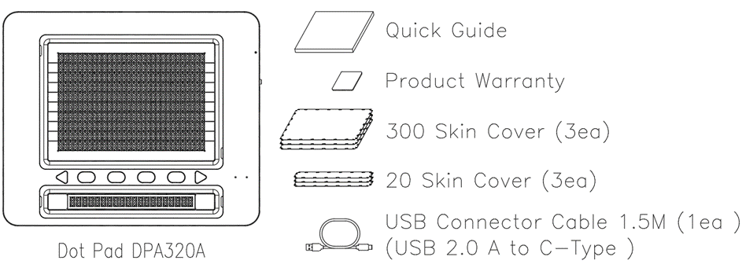
Configuration and Warranty | Dot Pad 320 | 1
Configuration and Warranty | 300-cell Protection Skin | 3 each
Configuration and Warranty | 20-cell Protection Skin | 3 each
Configuration and Warranty | Braille Quick Guide | 1
Configuration and Warranty | USB Cable 1.5M | 1
Configuration and Warranty | Warranty Period | 2 years

1.3. Dot Pad 320 Appearance
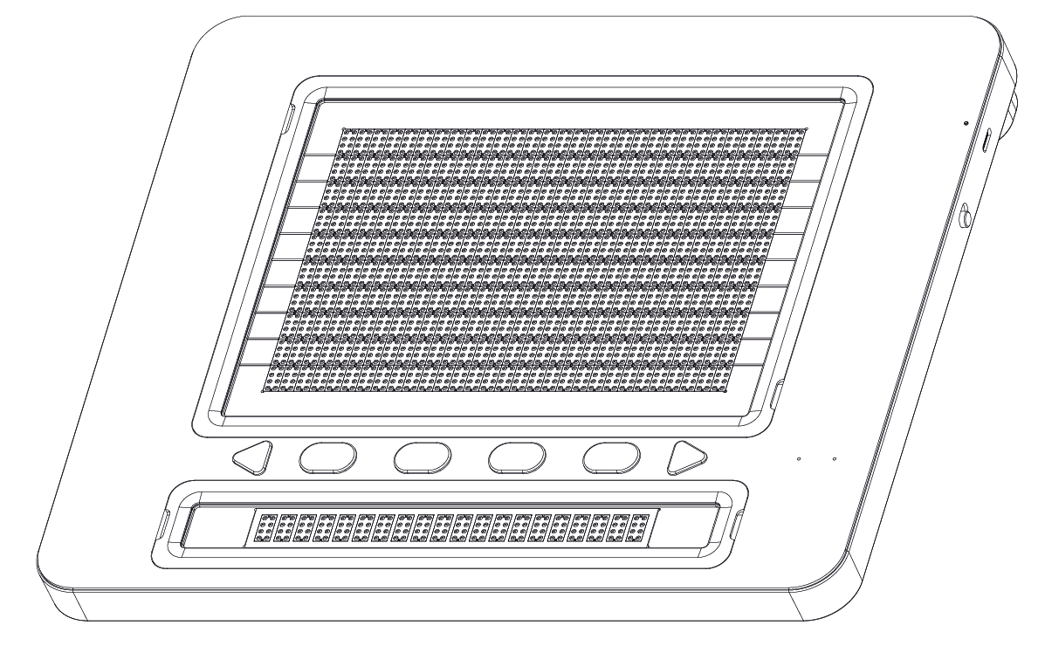
When the Dot Pad 320 is removed from the box and placed on the desk, it is in the correct position when the square body is slightly inclined away from the user.

1.3.1. Dot Pad 320 Top View
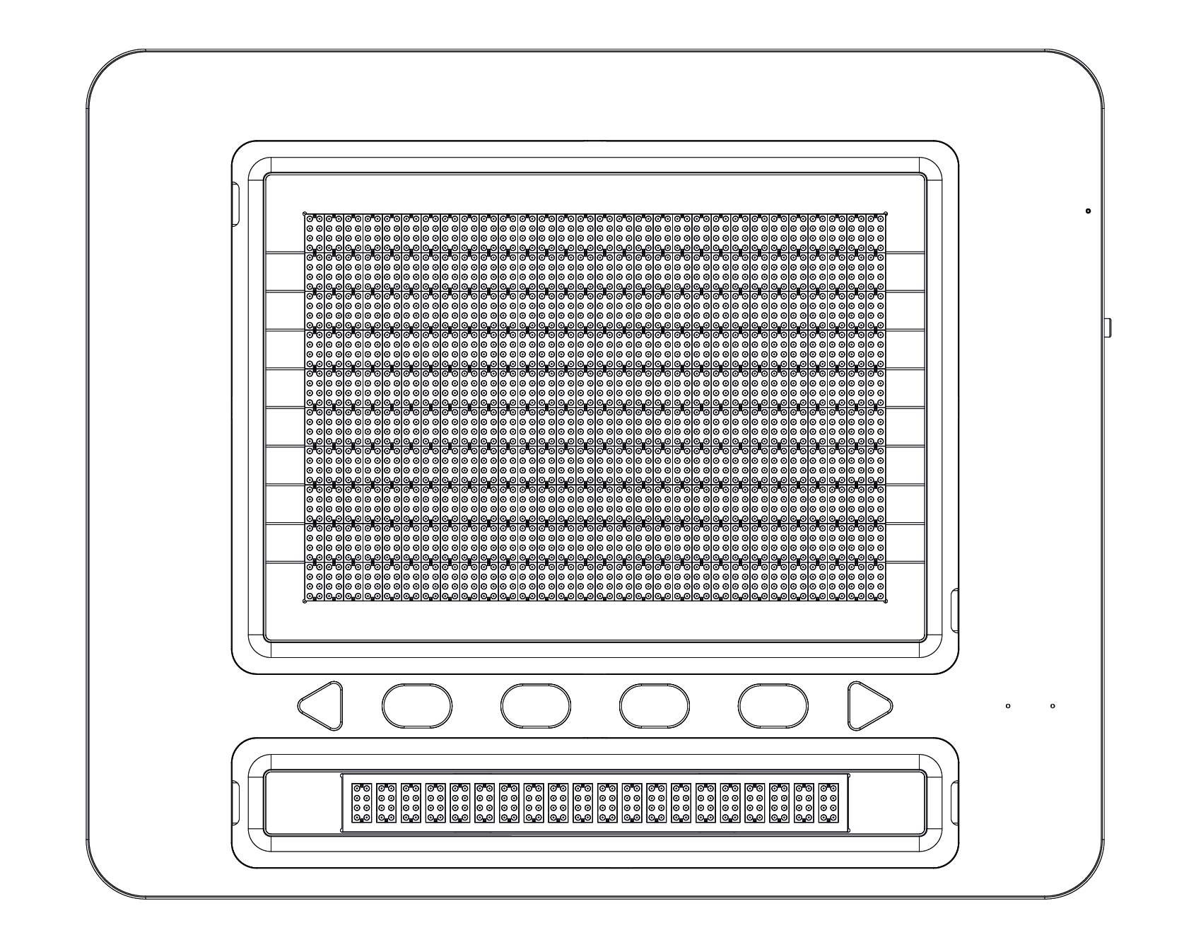
When the Dot Pad 320 is correctly oriented, the upper surface of the Dot Pad 320 consists of the following parts from nearest to farthest from the user:
- Braille Text Display Area: 20 braille cells are placed at standard braille intervals within a horizontally long rectangular frame, allowing the expression of 20 alphabets simultaneously.
- The Keyboard Area: Starting from the left to the right, the keyboard area consists of the Previous panning key, Function keys (F1 through F4), and the Next panning key. The shape of the panning keys is triangular, which distinguishes them from the other Function keys which are ovals.
※ Note: The panning keys are buttons that move the text display area to the previous or next line based to accommodate the 20 braille cells.
- Status Indicator (LED) Area: Located at the far right of the keyboard area, displays the connection and charging status of the device.
- The Graphic Area: The graphic area takes up the most space from the bird’s eye view with a total of 300, 8-pin cells (30 horizontal cells x 10 vertical cells). It is more compact compared to the braille text area and has equal spacing between the pins allowing clear representations of graphics. Additionally, it can also display multiple lines of braille text, making it versatile for both graphical and textual content.

1.3.2. Dot Pad 320 Right Side
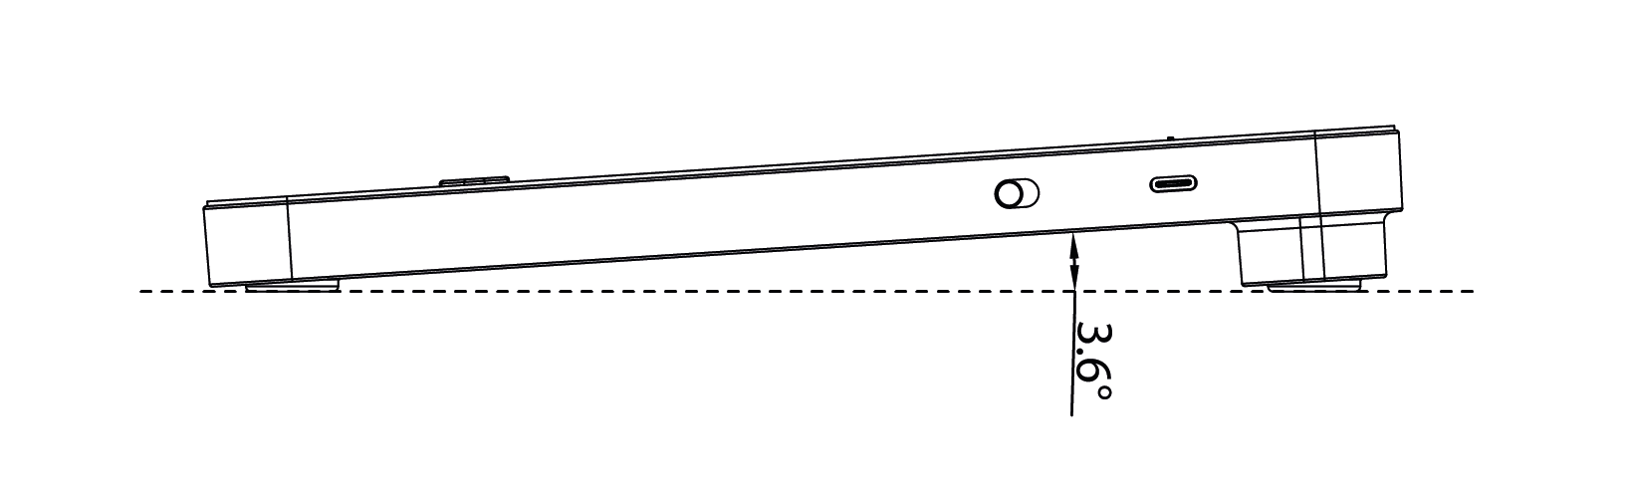
On the right side of the Dot Pad 320, starting from the rear to the front, there is a USB Type-C power charging port, followed by a power switch. The USB Type-C power port is a power only port. Keep in mind that there is no option of data transfer from this port.
The power switch powers on the Dot Pad when pushed up to the far side of the body. Long vibration feedback occurs when the device is turned on.

1.3.3. Dot Pad 320 Left Side
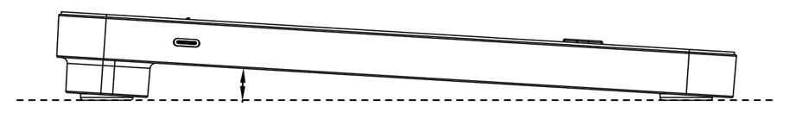

On the left side of the Dot Pad 320 there is a USB Type-C port designed specifically for data transfer which is restricted to administrative access only.

1.3.4. Dot Pad 320 Bottom Surface
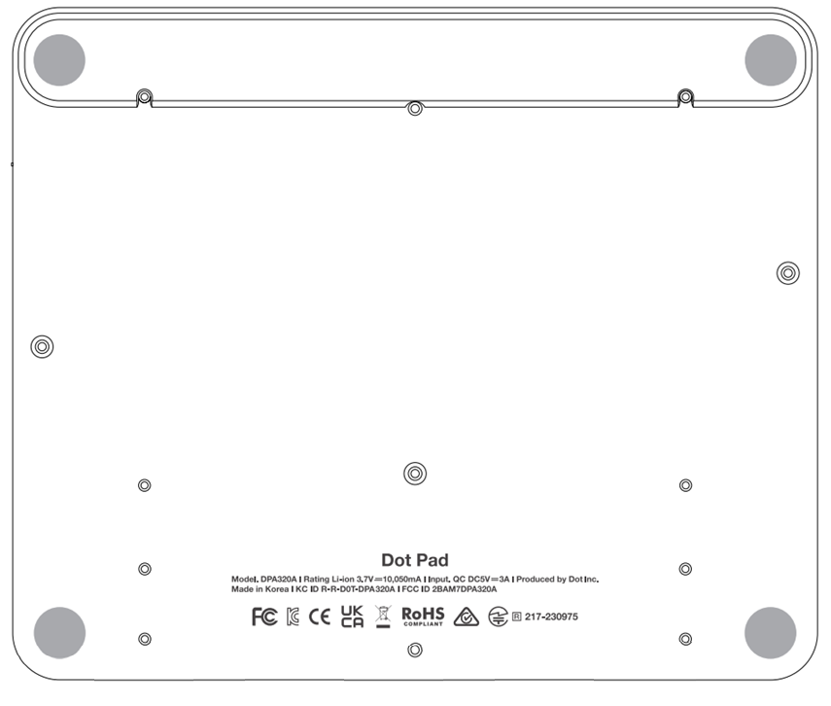

The bottom surface of the Dot Pad 320 has multiple screws that can be loosened when replacing the protective skin over the braille cells or replacing the battery of the Dot Pad 320. The batteries provided in the Dot Pad 320 are not detachable, so when replacing the batteries, be sure to replace them through Dot Inc. or a company authorized by Dot Inc. Please contact Dot Inc.’s customer service for more information.

1.4. Hardware Specifications
Table 1 Dot Pad 320 Hardware Specifications
Hardware Specifications | Tactile Display | 300 cells
Hardware Specifications | Braille Display | 20 cells
Hardware Specifications | Protective Skin | Graphics area (300 cells) /  Text area (20 cells)
Hardware Specifications | Processor | ARM Cortex-M4 32-Bit 120MHz
Hardware Specifications | RAM | 64 Kbyte
Hardware Specifications | Flash Memory | 128 Kbyte
Hardware Specifications | External Memory Support | None
Hardware Specifications | Wireless Connection | Bluetooth LE V5.0
Hardware Specifications | Sensor | None
Hardware Specifications | Camera | None
Exterior Specifications | Size (mm) | 273.5(W) x 228.5(D) x 31.0(H)
Exterior Specifications | Weight (g) | 1,200 g
Keyboard and Buttons | Function Keys | Function Key 4ea
Keyboard and Buttons | Panning Keys | Left, Right
Keyboard and Buttons | Power Switch | Power ON/OFF 1ea
Keyboard and Buttons | Keyboard | None
USB Interface | USB-C (left) | Data (admin access only)
USB Interface | USB-C (right) | Power and Charging
Audio and Video Interface | Speaker | None
Audio and Video Interface | Microphone | None
Audio and Video Interface | HDMI Video Output | None
Temperature Limitation | Operating Temperature | 0℃ ~ +40℃
Temperature Limitation | Storage Temperature | -20℃ ~ +70℃
Standby Time for Recovery to Operable Temperature | Recovery from min. Temperature | 24 hours  (for complete drying)
Standby Time for Recovery to Operable Temperature | Recovery from max. Temperature | 24 hours  (for complete drying)
Humidity Limitation | Operating Humidity | 20 ~ 75% R.H.
Humidity Limitation | Storage Humidity | 10 ~ 80% R.H.
Atmospheric pressure | Operating Atmospheric pressure | 500 ~ 1060 hPa
Atmospheric pressure | Storage Pressure Atmospheric | 500 ~ 1060 hPa
Charging and Battery | Battery | LI_ION BATTERY PACK, 3.60V, 10.05Ah, 36.18W[1S3P]
Charging and Battery | Charge | DC 5V 3A

1.5. Connectivity
Table 2 Dot Pad 320 Communication Specification
Communication (Bluetooth) | Specification | Bluetooth V5.0 (LE up to 10Kbps)
Communication (Bluetooth) | Output Power | 0 dBm
Communication (Bluetooth) | Data Rate | 10 kbps
Communication (Bluetooth) | Profile | GAP, GATT, SM, L2CAP and Integrated Public Profiles
Communication (Bluetooth) | Sensitivity | -90 dBm
Communication (Bluetooth) | Frequency Band | 2.402GHz ~ 2.480GHz

Basic Functions
In this section, you will get to know the different vibration patterns to test the Dot Pad 320’s state and ways to check the battery level.

2.1. Understanding Dot Pad 320 LED Signals
The LED indicator on the Dot Pad 320 provides various device status information based on its color and behavior. Users can receive information about the device when it is powered on or during charging.

Table 3 Dot Pad 320 Status Based on LED Color and State After Powering On
LED Color / State | Explanation
Blue / Blinking | Searching for connectable device
Blue / Turned on | Connected to device

Table 4 Dot Pad 320 Status Based on LED Color and State During Charging
LED Color/State | Explanation
Red / Blinking | Charging error
Red / Turned on | Charging
Red / Turned off | Fully charged or device is in low battery

2.2. Understanding Device Information Through the Dot Pad 320’s Vibration Signals
The vibration pattern of the Dot Pad 320 informs the user regarding the Dot Pad 320’s battery level, Bluetooth connection status, power status, etc.

Table 5 Dot Pad 320 Vibration Pattern and its corresponding status
Status | Vibration Pattern
Power On | One long vibration
Power Connection | Once the power cable is connected successfully, vibration will indicate the battery status
Battery Level | 1~5 vibrations (according to the battery level)
Bluetooth Connected | Two long vibrations

2.3. Checking the Battery Level
To check the battery level of the Dot Pad 320, you can press and hold the previous and next panning keys at the same time for at least 1.5 seconds while powered on, and then release them. The levels for displaying the remaining battery are divided into 5 levels and are notified by vibration feedback.

Number of Vibrations | 5 | 4 | 3 | 2 | 1
Battery Level | Above 80% | 60% ~ 80% | 40% ~ 60% | 20% ~ 40% | Below 20%
※Please connect the power cable if the battery level is below 20%

2.4. Checking the Charging Status
When the Dot Pad 320 is charging successfully, there will be delayed vibration feedback of the battery level indicating that the Dot Pad 320 is charging. Please take note that there will be no vibration feedback if you plug in the charger while the device is turned off.
※If you have plugged the charging cable in while the device is turned off, please turn the Dot Pad 320 on to check the charging status.

Using the Dot Pad 320
The Dot Pad 320 is a braille display that can be connected to other devices such as laptop, iPad, or iPhone. It offers new experience in using braille and tactile graphics through software services developed based on the Dot Pad SDK, along with screen readers like VoiceOver and NVDA, providing multi-line and tactile graphic braille device experience.

3.1. Using the Dot Pad 320 with Dot Canvas
Dot Canvas is a versatile digital tool for the Dot Pad 320 developed by Dot Inc., available as both an app and a web-based platform. It allows users to create, edit, save, and share tactile graphics and braille text. Tailored for visually impaired and blind users, Dot Canvas facilitates the creation of rich, multi-sensory content, enhancing learning, creativity, and accessibility. For comprehensive usage instructions, please refer to the most recent ‘Using the Dot Pad 320 with Dot Canvas’ manual.
Download link: Using the Dot Pad 320 with Dot Canvas
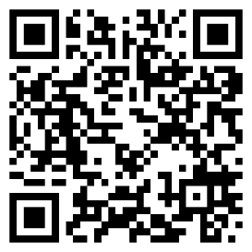

3.2. Using the Dot Pad 320 with VoiceOver
VoiceOver, Apple’s advanced screen reader, provides auditory and tactile feedback to assist visually impaired users. When paired with the Dot Pad 320, VoiceOver offers tactile feedback for both text and graphics, delivering a comprehensive and intuitive accessibility solution. This combination enhances user interaction with their devices. For detailed guidance, please refer to the most recent ‘Using the Dot Pad 320 with VoiceOver’ manual.
Download link: Using the Dot Pad 320 with VoiceOver
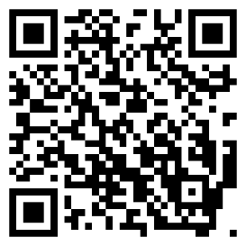

3.3 Using the Dot Pad 320 with NVDA
NVDA (NonVisual Desktop Access) is a free, open-source screen reader for Microsoft Windows, developed by NV Access. Dot Inc. offers an NVDA driver for the Dot Pad 320, enabling seamless integration and enhancing the tactile graphic display experience. To maximize the benefits of using the Dot Pad 320 with NVDA, please refer to the most recent ‘Using the Dot Pad 320 with NVDA’ manual.
Download link: Using the Dot Pad 320 with NVDA
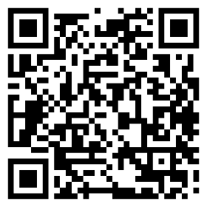

Handling and Safety Precautions
The contents of this manual may differ from the actual product, depending on the software version of the product, the specifications of the model, and the user's settings. Do not use the product for any purpose other than the intended purpose. Use with caution as the product may be damaged if impacted.

- Keep the Dot Pad 320 dry. If used in a humid place or becomes wet, the product may not work properly.
- The Dot Pad 320 has a built-in magnet. Do not place it close to other magnetic products or metals. There is a risk of damage to the product.
- Use the Dot Pad 320 on a table away from the body and when used in a dusty area, foreign objects may get inside and interfere with the device’s operation.
- Only use accessories provided by Dot Inc. Use of other third-party accessories may cause the product to malfunction and may result in the user not receiving the warranty services provided by Dot Inc.
- The Dot Pad 320 has passed the EMC (Electromagnetic Compatibility) test. Situational or environmental variables may still cause interference or affect signals via surrounding products. Heat generation and malfunction issues may occur.
- The Dot Pad 320’s wireless conducting power follows the RF (Radio Frequency) standard. However, if the voltage and temperature are not within the standard range, the product's wireless conducting power may be unstable and could impact the performance.
- The Dot Pad 320 has passed the RSE (Radiated Spurious Emission) test. However, if the Dot Pad 320 is used with non-component accessories, it may cause malfunction.
- The Dot Pad 320’s Short Range Wireless Communication function satisfies the data transfer security standards. However, if the software or firmware is modified or changed without authorization, the product’s data transfer security may operate abnormally.
- The Dot Pad 320’s wireless communication antenna has passed the SAR (Specific Absorption Rate) test measured by qualified equipment. If any abnormal operating method is applied, the product’s antenna performance may change.
- The Dot Pad 320 has passed all qualification tests mentioned above by qualified laboratories. However, if the product is placed in different conditions that could cause functional errors or is applied to atypical operation methods, the product may operate abnormally. It is advised to turn off the device, disconnect the power, stop using the device, and contact customer service.
- If pressure is applied while the braille cells are moving, the product may not function normally. In this case, it is not a breakdown, so we suggest you remove your hand and try to print the desired image again.
- If the product is used in the opposite direction, it may not be able to represent the image or braille correctly.
- Some product specifications are subject to change without notice to better serve you.
- If the Dot Pad 320’s firmware provided by Dot Inc. is changed or applied to the product through an unofficial channel, it may cause damage to the product or cause errors. In this case, the warranty service is voided.
- Since the Dot Pad 320 has the possibility of radio interference during use, it cannot perform services related to human safety.
- When charging the Dot Pad 320, the product temperature may rise, and if the temperature of the battery rises above a certain level, the charging may be automatically stopped for safety reasons.

Use safety in the following situations:

1. Do not use the Dot Pad 320 in a severe lightning storm.
During severe lightning and thunder, refrain from using the product and disconnect the charger from the power source. Continuing its use can cause injury, fire, or device malfunction.

2. Do not use the Dot Pad 320 in prohibited areas.
Do not use the Dot Pad 320 in areas where use of the product is prohibited, such as in airplanes or hospitals. Electronics and communication products can be affected by electromagnetic waves.

3. Never disassemble and modify.
Do not disassemble or shock the product. There is a risk of electric shock, short circuit, or fire. Warranty services do not cover disassembly of the product. If your device needs service, contact customer service at your local distributor or contact Dot Inc. Do not use it in a damaged or broken state as it may cause fires, burns, and electric shock. In this case, please stop using the product and contact customer service.

4. Use only the correct power cable and an appropriate power outlet.
Please connect and use the USB cable correctly to avoid the charging cable from loosening. Do not bend, pull, heat, cut, or loosen the cables as it may cause fire or electric shock. When not in use, disconnect the charger's cable. There may be a risk of electric shock if the device is used while charging. When removing the adapter, hold the adapter and remove it. If you remove the adapter by pulling the cable, a disconnection within the cable may cause charging failure.

5. Avoid high temperatures and humid environments.
Do not use the product in a hot and humid place. If the product gets wet, turn it off and dry it thoroughly before reusing. Do not place it on duvets, carpets, household electric appliances, or in direct sunlight (such as car seats) for extended periods. The exterior may become deformed, broken, or explode. If the temperature of the product sharply rises, stop using the product and contact customer service.
*Operating Temperature: 0℃ ~ +50℃, Storage Temperature: -20℃ ~ +60℃

6. Do not use any chemicals.
Never use chemicals such as alcohol or benzene to clean the Dot Pad 320. This may start a fire. If any foreign objects get on the product or charger, wipe it with a soft cloth.

7. Avoid metal and magnetism.
Do not keep the charging ports close to any metal such as necklaces, keys, coins, nails, watches, etc. If a metal object is short circuited with the charging port, there is a risk of explosion. Do not store your Dot Pad 320 near magnetic fields. Magnetic fields can impact your device. It may cause a malfunction from exposure to magnetic fields.

8. Use special caution for children and pets
Store products, chargers, parts, etc. out of reach of children or pets. If the product, charger, or parts gets in your mouth or is striked, you may be at risk of electric shock or exposure to electromagnetic waves. Be careful not to allow children or pets to swallow products, chargers, parts, etc. There is a risk of suffocation, explosion, and fire.

9.Do not use in an explosive atmosphere.
Do not use the product in explosive areas. This may affect high-frequency devices. Do not place the product on an unstable surface, such as on a shaky or sloping area. The device’s fall may cause injury or damage to the product.

10. Be aware of fire risks.
Do not cover or wrap the Dot Pad 320 with fabric materials such as a blanket during use or when charging. Do not dispose of the device with general waste. It can cause fires, explosions, and environmental pollution.

11. Avoid excessive contact under heated conditions.
Avoid using the product when the temperature on the surface of the product rises above the appropriate level. If you come into contact with the product in this state for a long time, there is a risk of burns or disturbing skin pigmentation. If the external protective cover comes off or you experience an allergic reaction to the material of the product, stop using the product immediately and consult a physician.

12. Keep the Dot Pad 320 in a safe place for storage.
When not in use for a long time, disconnect the charger from the Dot Pad 320 and store it in a safe place. When storing the charger, be careful not to severely fold or twist the USB cable. If the USB cable is stored or used with an excessive fold or twist, the silicone coating of the cable can be stripped off or the cable may break and cause a failure or accident.

13. Be careful in handling the battery.
In hot and humid places, the battery may not charge well or may drain quickly. Do not expose it to direct sunlight or use the device in a humid place, such as a bathroom.
- If you want to use the Dot Pad 320 after a long period of unuse, please use it again after fully charging.
- Please note that it may explode if the battery is forcibly removed.
- Do not change, modify, or expose the Dot Pad 320 to liquids. Once the device is fully charged, disconnect the charger from the outlet and the device to avoid unnecessary power consumption.
- Please bring your product and charger with you when you visit a service center due to battery problems.
- If the product gets heated while charging, please wear gloves or use a tool other than your body to separate the charger and the Dot Pad 320.
- Overheating may cause damage to the product. If the device overheats while charging, please unplug the USB charging cable and contact a Dot Inc. licensed service center.

14. Do not give any shock or impact.
If you apply strong force to the device, place heavy objects on top, etc., it may cause an impact to the product. This may damage your device, cause malfunction, or shorten its lifespan. This may also cause overheating, combustion, or fire. When not in use, store it in a safe place to avoid shock and damage to the device.

15. Do not use chargers that have not been approved.
Avoid using unapproved chargers as it may lead to damage of the battery causing injury to the user or the device.

Customer Support
For any inquiries, support, or additional information, you can contact Dot Inc. at the following:
Dot Email: inquiry@dotincorp.com
Dot Phone Number: +82) 2-864-1113
Dot Homepage: https://www.dotincorp.com/

Product Certifications
South Korea: KC (KC ID: R-R-D0T-DPA320A)
United States: FCC (FCC ID:2BAM7DPA320A)
Europe: CE
United Kingdom: UKCA
Japan: Japan MIC (ID: 217-230975)
Australia: RCM

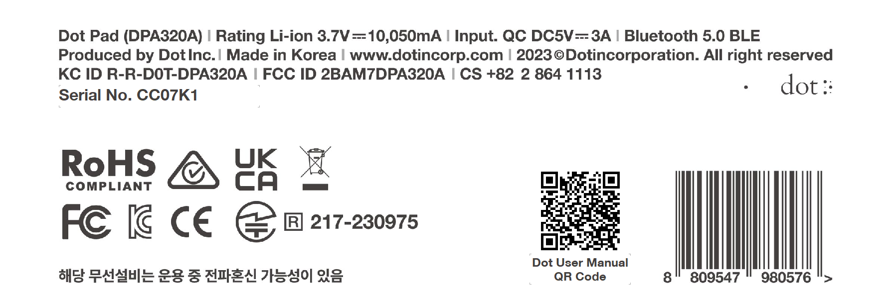

1. KC: Korea Certification
※ The wireless equipment in use may cause radio interference.
※ The manufacturer and installer cannot provide services related to human safety as the wireless equipment may cause radio interference.

2. FCC: Federal Communications Commission

FCC Class A
This equipment has been tested and found to comply with the limits for a Class A digital device, pursuant to Part 15 of the FCC Rules. These limits are designed to provide reasonable protection against harmful interference when the equipment is operated in a commercial environment. This equipment generates, uses, and can radiate radio frequency energy and, if not installed and used in accordance with the instruction manual, may cause harmful interference to radio communications. Operation of this equipment in a residential area is likely to cause harmful interference in which case the user will be required to correct the interference at his own expense.

FCC Class B
This equipment has been tested and found to comply with the limits for a Class B digital device, pursuant to Part 15 of the FCC Rules. These limits are designed to provide reasonable protection against harmful interference in a residential installation. This equipment generates, uses, and can radiate radio frequency energy and, if not installed and used in accordance with the instructions, may cause harmful interference to radio or television reception, which can be determined by turning the equipment off and back on, the user is encouraged to try to correct the interference by one or more of the following measures:
- Reorient or relocate the receiving antenna.
- Increase the separation between the equipment and receiver.
- Connect the equipment into an outlet in a circuit different from that to which the receiver is connected.
- Consult the dealer or an experienced radio/TV technician for help.

Caution
The manufacturer is not responsible for any radio or TV interference caused by unauthorized changes or modifications to this equipment. Such changes or modifications could void the user's authority to operate the equipment.
This equipment must be installed and operated in accordance with the instructions provided and the antenna(s) used for this transmitter must be installed to provide a separation distance of at least 20 cm from all persons and must not be co-located or operating in conjunction with any other antenna or transmitter.
All rights reserved. This manual may not be reproduced in any form. Even in part, or duplicated or processed using electronic, mechanical, or chemical processes without the written permission of the publisher. This booklet may contain errors or misprints. The information it contains is regularly checked and corrections are included in subsequent editions. We disclaim any responsibility for any technical error or printing error, or their consequences. All trademarks’ patents are recognized.

3. CE: European Conformity

“CE” mark indicates that this product complies with the European requirements for safety, health, environment, and customer protection. “CE” mark devices are intended for sales in Europe.

4. WEEE: Waste from Electrical and Electronic Equipment

This symbol [crossed-out wheeled bin WEEE Annex Ⅳ] indicates separate collection of waste electrical and electronic equipment in the EU countries. Please do not throw the equipment into the domestic refuse. Please use the return and collection systems available in your country for proper disposal of this product.

Disclaimer
No warranty or representation, either expressed or implied, is made with respect to the contents of this documentation, its quality, performance, merchantability, or fitness for a particular purpose. The information presented in this documentation has been carefully checked for reliability; however, no responsibility is assumed for inaccuracies. The information contained in this documentation is subject to change without notice.
In no event will Dot Inc. be liable for direct, indirect, special, incidental, or consequential damages arising out of the use or inability to use this product or documentation, even when advised of the possibility of such damages.

[FCC and CE Compliance Statement]
These limits are designed to provide reasonable protection against frequency interference in residential installation. This equipment generates uses and can radiate radio frequency energy, and if not installed or used in accordance with the instructions, may cause harmful interference to radio communication. However, there is no guarantee that interference will not occur in television reception, which can be determined by turning the equipment off and on.
The user is encouraged to try and correct the interference by one or more of the following measures:
- Reorient or relocate the receiving antenna.
- Increase the separation between the equipment and the receiver.
- Connect the equipment into an outlet on a circuit different from that to which the receiver is connected to.

