

**User Guide**

**Using the Dot Pad 320**

**with Dot Canvas**

**Dot Incorporation**

08507

146, Gasan Digital 1-ro, Geumcheon-gu, Seoul, Korea

Room 403 (Daeryung Techno Town 22nd)

Phone Number: +82) 2-864-1113

Fax: +82) 2-864-1989

Email: inquiry@dotincorp.com

Homepage: www.dotincorp.com

## Table of Contents

Table of Contents 2

1. Introduction 3

1.1. Introduction to Dot Canvas 3

1.2. System Requirements 3

2. Using Dot Canvas App 3

2.1. Introduction to Dot Canvas App 3

2.2. Starting Dot Canvas App 3

2.2.1. Downloading Dot Canvas App 3

2.2.2. Creating an Account 3

2.2.3. Logging In 4

2.2.4. Finding Forgotten Username/Password 4

2.2.5. Screen Layout of Dot Canvas App 4

2.3. Connecting Dot Canvas App with the Dot Pad 5

2.3.1. Troubleshooting Connection Issues 5

2.3.2. Disconnecting the Dot Pad 5

2.4. Using Dot Canvas App Features 5

2.4.1. Create Canvas 5

2.4.2. My Drawings 8

2.4.3. Dot Cloud 8

2.4.4. Settings 9

2.4.5. Using the Dot Pad buttons in Dot Canvas App 9

3. Using Dot Canvas Web 11

3.1. Introducing Dot Canvas Web 11

3.1.1. Screen Layout of Dot Canvas Web 11

3.2. Starting Dot Canvas Web 12

3.3. Connecting Dot Canvas Web to Dot Pad 12

3.3.1. Troubleshooting Connection Issues 12

3.3.2. Disconnecting the Dot Pad 12

3.4. Using Dot Canvas Web Features 13

3.4.1. Create Canvas 13

3.4.2. Dot Cloud 16

3.5. Updating Firmware Through Dot Support 17

## Introduction

### Introduction to Dot Canvas

Dot Canvas is a versatile digital tool designed for the Dot Pad, offering both an app and a web-based platform to create, edit, save, and share tactile graphics and braille text. Tailored to the needs of visually impaired and blind users, Dot Canvas enables the creation of rich, multi-sensory content, empowering users to design and interact with tactile information in ways that enhance learning, creativity, and accessibility.

It provides a comprehensive solution for creating and managing tactile content, making it an essential tool for users seeking to leverage the full capabilities of the Dot Pad in various contexts, from education and professional use to personal projects.

### System Requirements

**Dot Canvas APP**

- Operating Systems: iOS/iPadOS

- Download: Available on the Apple app store by searching for ‘Dot Canvas.’

*※ For Optimal drawing experience, using the app with an iPad is recommended.*

**Dot Canvas Web**

- Hardware Requirements: PC with Bluetooth support

*※ Dot Canvas Web is optimized for use with the Chrome browser*

## Using Dot Canvas App

### Introduction to Dot Canvas App

Dot Canvas App is an iPhone/ iPad application that can be used in connection with the Dot Pad, enabling users to create and display tactile information such as dots, lines, shapes, images, and text.

It empowers visually impaired and blind users to design and modify their own tactile graphic content. Users can simply save the content to “My Drawing,” “Personal Drive,” or share them on the “Public Drive.” The tactile graphics, whether saved or shared, can be easily accessed and displayed on the connected Dot Pad.

### Starting Dot Canvas App

#### Downloading Dot Canvas App

Search for “Dot Canvas” in the Apple App Store and download it.

Dot Canvas App icon
 Dot Canvas App

*※ Dot Canvas App is an application developed by Dot Incorporation*

#### Creating an Account

Dot Canvas is provided as an app and a website. Users can create one account to access both versions and experience the same tactile graphic content saved in their Personal Drive. Account registration is available through both the app and the website. Account registration method through the Dot Canvas App is as follows:

* After launching Dot Canvas App, select the [Create Account] button.
* When the “Create A New Account” page comes up, fill in the required information.
* Enter the verification code issued through the email you entered.
* Complete account registration after entering the required additional information.

#### Logging In

After completing the account registration, you can log in to Dot Canvas App by entering your registered username and password.

* When Dot Canvas App is launched, the login screen appears, and the username input window is focused.
* Enter your username and password you created and select the Login button to move to the main screen.

*※ If you enter your username and password and select the Remember ID button, the entered username information is maintained when you log in again.*

#### Finding Forgotten Username/Password

In case you lose your username or password, you can reset your password in the following steps:

* If you lose your username, select the [Forgot Username?] button and enter the name and registered email address.
* If you lose your password, select the [Forgot Password?] button and enter your username.
* Check the verification code sent to the registered email and enter it.
* Check the username or reset your password with a new one.

#### Screen Layout of Dot Canvas App

The main screen of Dot Canvas App consists of the following sections:

1. Create Canvas

* Create and edit the tactile graphic content using various drawing tools.
* As you draw on Dot Canvas App, the content is automatically displayed in real-time on the Dot Pad.

1. My Drawing

* Save the content you create directly onto your device.
* Content saved in “My Drawing” can be printed on the Dot Pad without requiring an internet connection.

1. Dot Cloud

* Dot Cloud is a cloud storage service where you can save and access your content in an Internet-connected environment.
* You can save the content you create in your Personal Drive or share them in the Public Drive.

1. Settings

* Connect or disconnect from the Dot Pad.
* Select the braille language to be displayed on 20 cells of the Dot Pad

1. Profile

* View the user's registered name and username.
* Log out of Dot Canvas App.

### Connecting Dot Canvas App with the Dot Pad

After logging in to Dot Canvas App, it will be directed to the main screen. Users can connect Dot Canvas App to the Dot Pad via Bluetooth. To connect the Dot Pad, please follow the steps below:

* From the main screen, go to [Setting] > [Connect]
* Select the Dot Pad Bluetooth number you wish to connect to.
* When the connection is successful, the Dot Pad will vibrate twice.

#### Troubleshooting Connection Issues

If the Dot Pad you wish to connect to does not appear in the connection list, please check 3 things below:

1. Make sure the Dot Pad is turned on.

: If the Dot Pad is turned off, turn it on and select the [Refresh] button in the connection list.

1. Make sure the device’s Bluetooth running Dot Canva App is turned on.

: If the device’s Bluetooth is turned off, please turn it on and select the [Refresh] button in the connection list.

1. Check whether VoiceOver is paired with the Dot Pad.   
   : If the Dot Pad is paired with VoiceOver braille display, please disconnect the Dot Pad with VoiceOver braille display in the following order.

* Apple [Settings] > [Accessibility] > [VoiceOver] > [Braille]

※ *You can go to [Settings] > [Accessibility] > [VoiceOver] by selecting the Apple Settings button in the pop-up window.*

* Focus the connected Dot Pad at the bottom of the screen and swipe up to go to More Information.
* Select [Forget this Device] to disconnect the Dot Pad.

#### Disconnecting the Dot Pad

To disconnect the currently connected Dot Pad, please follow the steps below:

* From the main screen of Dot Canvas APP, navigate to [Setting]
* Select the [Connect] button.
* The disconnection will be confirmed by the Dot Pad vibrating twice.

### Using Dot Canvas App Features

#### Create Canvas

Using various drawing tools, users can freely create pictures by drawing shapes and add textual descriptions for the picture. The graphics created through Dot Canvas App are displayed on the 300-cell part of the Dot Pad in the form of tactile graphics, and the text descriptions are displayed in braille on the 20-cell part of the Dot Pad.

The layout of the Create Canvas screen is as follows:

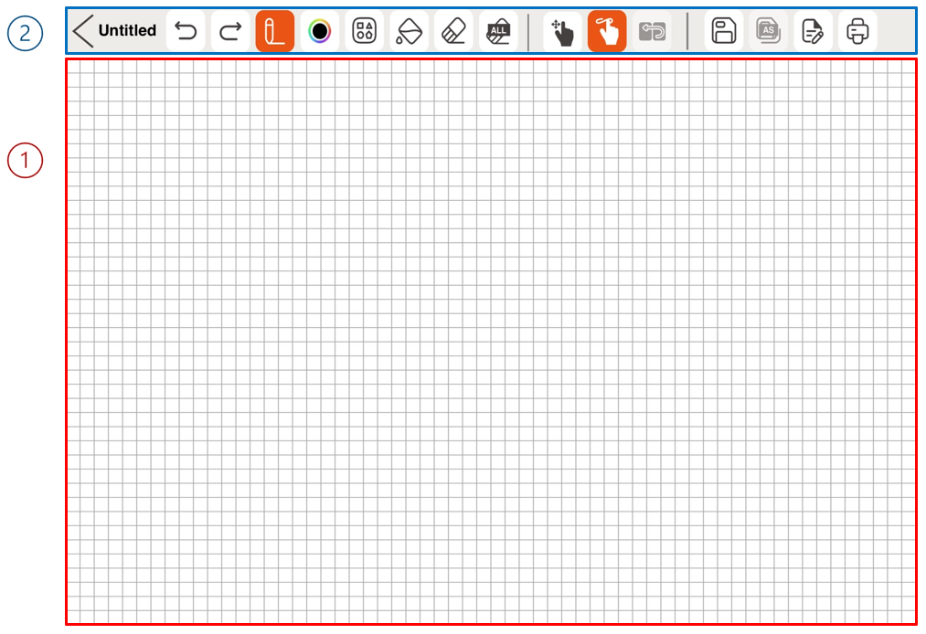

1. Canvas: Occupying the largest area of the screen, the canvas is where users can draw tactile content by touch.
2. Drawing Menu Bar: Located at the top of the screen, it is a collection of various drawing tools that can be used for creating and modifying tactile content.

Table 1 Dot Canvas App Drawing Tools

|  |  |  |  |
| --- | --- | --- | --- |
| Back icon. | **Back**  Exit the Canvas Creation screen and return to the main screen.  If you press the Back button while creating tactile graphics, a warning window will prompt you to save your progress. Choosing [No] closes the window, while selecting [Save] allows you to name the file and choose a save location. The file will be saved in either My Drawings or Dot Drive, based on your selection. |  | **File Name**  File name on which you are working. |
| Undo/Redo icon. | **Undo/Redo**  Undo or redo the latest work. |  | **Pen**  Draw freely, just as you draw with a pen. |
|  | **Low Vison Pen mode**  Select a pen color that best suits your vision needs. There are four colors: Black, Blue, Yellow, Red |  | **Line**  Select and adjust th.3e desired length with one finger on the screen to draw a line. |
|  | **Square/Rectangle**  Select and adjust the desired size with one finger on the screen to draw a square or rectangle. |  | **Circle**  Select and adjust the desired size with one finger on the screen to draw a circle. |
|  | **Triangle**  Select and adjust the desired size with one finger on the screen to draw a right triangle |  | **Fill**  Fill an area made up of lines to be blacked out with dots. |
|  | **Erase**  Erase the area you want to clear. |  | **Clear All**  Erase all the paintings on the canvas at once. |
|  | **Save**  Save your work by pressing the Save button, which opens a pop-up to choose a storage location. The file will be saved in My Drawings or Dot Drive after you select the location and enter a file name. |  | **Canvas Navigation Mode**  This mode allows users to explore the position of their fingers on the screen before starting to draw. |
|  | **Drawing Mode**  This mode allows users to draw on the canvas. |  | **Menu Navigation Mode**  This mode is used to navigate and select drawing tools in the Dot Canvas app. (While VoiceOver is enabled) |
|  | **Save As**  If you modify an existing saved file, you can change the file name and save it. |  | **Pages**  • Displays a pop-up where you can create or delete a page and add a page description.  • The bottom of the pop-up shows arrow buttons and current page details for navigation.  • When inserting page description, it is automatically saved and translated into 20-cell display of the Dot Pad after the pop-up is closed. |
|  | **Print**  Print the picture you worked on to Dot Pad. |  | |

1. Zoom In & Out

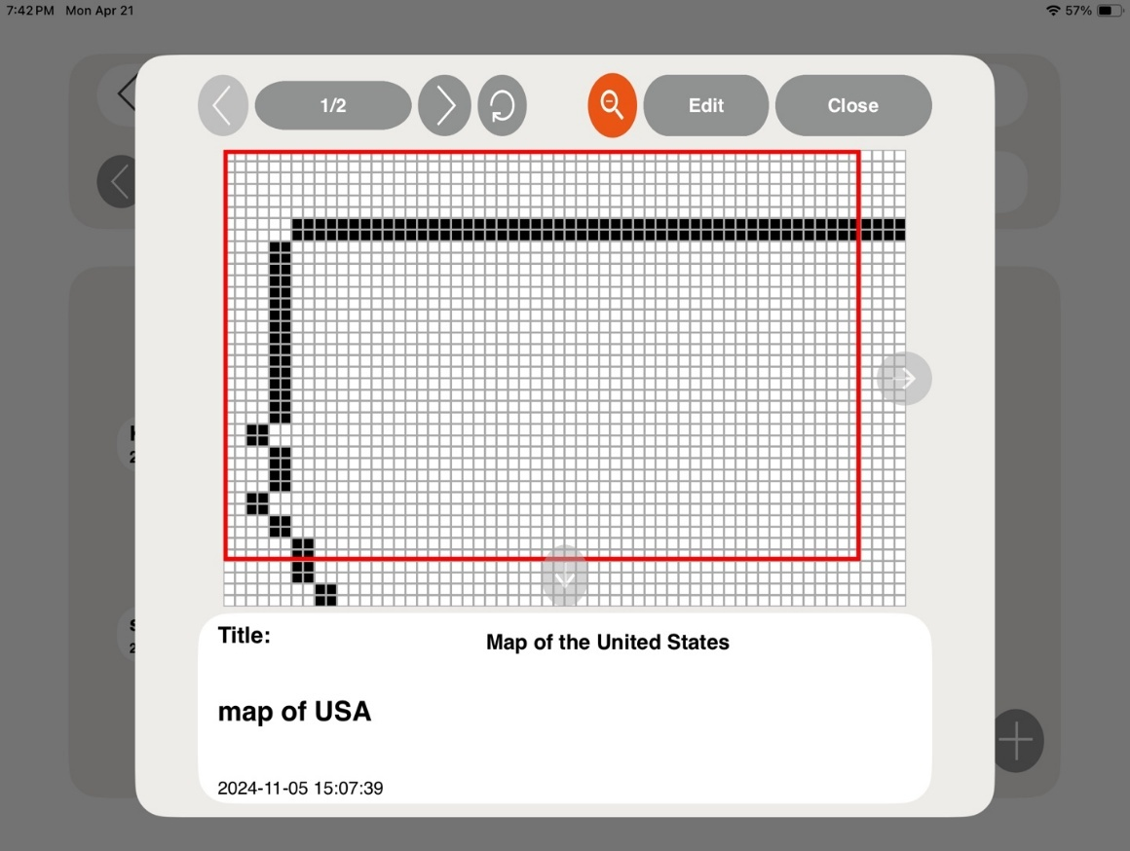

* Zoom In & Out offers a zoomed-in view of a specific area.
* To zoom in on a file, tap the magnifying glass icon at the top of the pop-up window. A red indicator box will appear over the content.
* Use the **F1** and **F4** keys of Dot Pad to move the box left and right, or up and down.
* Press **F2** and **F3** together to switch the movement direction between horizontal and vertical.

#### My Drawings

Dot Canvas App enables users to create or modify tactile graphic content and save it to their device’s internal storage. In the "My Drawing" section, users can view a list of files stored internally. If many files are saved, the search bar allows users to quickly find specific files by entering the file name. Each file contains the file name and the date it was created.

When selecting the file name, a context menu is displayed, and the first picture of the file is displayed on the Dot Pad. The components of the context menu are as follows:

* Open: Run the selected file. When the file runs, the picture on the first page and the description of the picture are displayed on the Dot Pad. Users can go to the previous/next page and modify the picture and description by clicking the [Edit] button.
* Delete: Deletes the selected file.
* Rename: Modify the saved file name.
* Exit: Exit the context menu.

#### Dot Cloud

Users can save their personal content and open various public content through Dot cloud, a cloud-based tactile graphic content online storage service provided by Dot Inc.

1. Personal Drive
   * Users can upload tactile graphic content created in Dot Canvas App to their Personal Drive. This cloud-based personal storage allows access to content across multiple devices without restrictions.
2. Public Drive
   * Users can explore various shared tactile graphic content organized by themes and share their own drawings with the Public Drive for others to access.

#### Settings

Set up the Dot Pad connection or select a braille language supported by Dot Canvas App

1. Connect or Disconnect Dot Canvas App with the Dot Pad
2. Select the braille language.

* Select the braille language to be displayed on the 20-cell display of the Dot Pad.
* Braille language must be in correspondence with input language.
* The 23 braille languages currently supported by Dot Canvas App are as follows:

Korean, English, Chinese, Japanese, Vietnamese, Thai, Arabic, French, Italian, Spanish, Catalan, German, Czech, Polish, Norwegian, Russian, Portuguese, Danish, Greek, Swedish, Finnish, Kazakh, Khmer.

#### Using the Dot Pad buttons in Dot Canvas App

1. Navigating the 20-cell text display on the Dot Pad

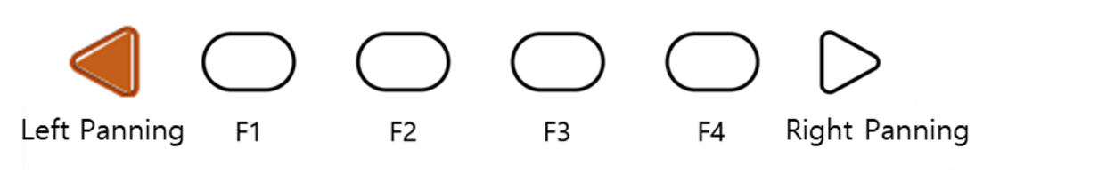

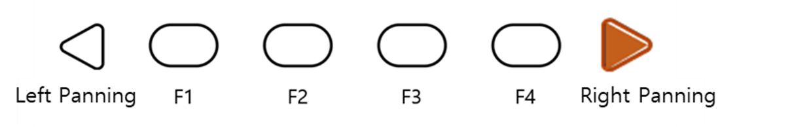

* If the content in the 20-cell text area becomes lengthy, users can navigate through the content using the panning key buttons.
* Right panning key button: Move to the next line (20 cells)
* Left panning key button: Move to the previous line (20 cells)

1. Navigating the 300-cell graphic and multi-line display on the Dot Pad

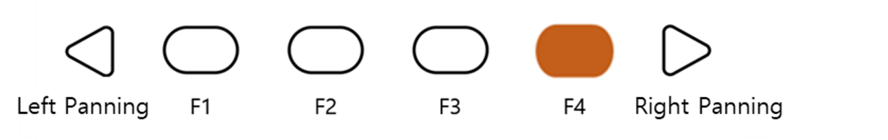

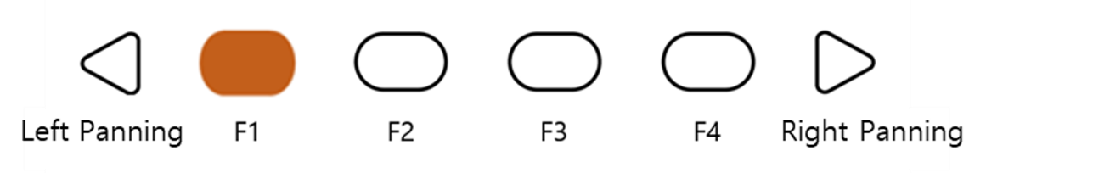

* If the content in the 300-cell graphic/multiline area becomes lengthy, users can navigate through the content using the F1 and F4 buttons.
* F4 button: Move to the next page (300 cells)
* F1 button: Move to the previous page (300 cells)

1. Dot Pad Shortcut buttons for drawing tools

When connecting the Dot Pad to the Dot Canvas app, users can easily use various functions by using the Dot Pad buttons.

* Select Pen Tool

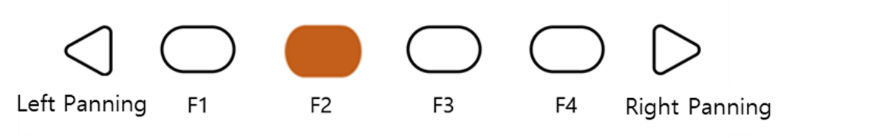

In the Create Canvas page, pressing the F2 button will select the 'Pen Tool' among the drawing tools.

* Erase All

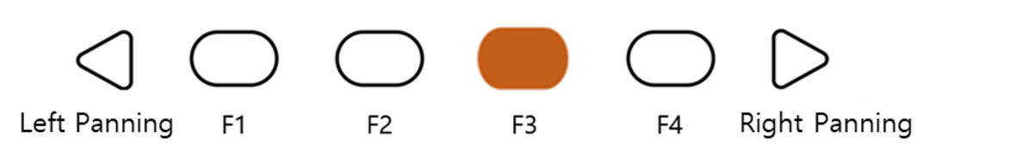

Users can press the **F3 key** to activate the **undo** function in the drawing tool.

* Add a New Page

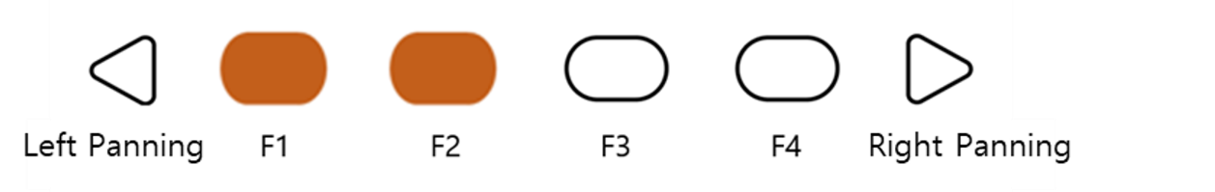

Users can press F1 and F2 together to add a new page to the canvas. Users can move to the next page by pressing the F1 and F4 buttons.

* Delete Current Page

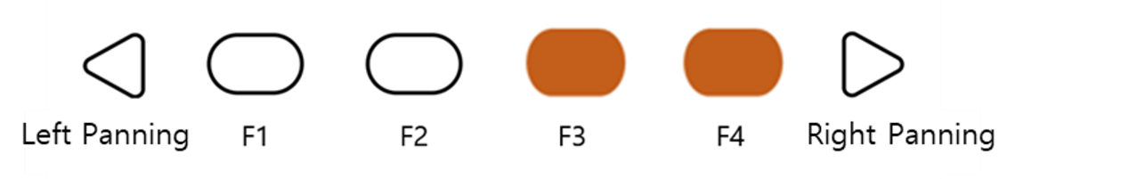

Users can delete their current canvas by pressing the F3 and F4 button together. After deleting the page, users can move pages with buttons F1 and F4.

* Changing Canvas Mode

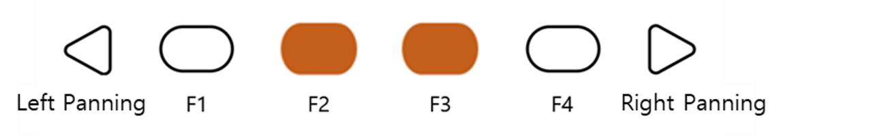

As a user-friendly application, Dot Canvas provides a mode that allows visually impaired users to draw and use the tools easily. Users can press F2 and F3 together to change the mode.

*※ Types of Canvas Mode*

1. Canvas Navigating Mode

: Before drawing on the iPad, users can find the position of their finger.

If they touch the iPad screen in navigating mode, the Dot Pad will display the

Position of the finger with a crosshair cursor. When the finger stops at a certain

position, the cursor will start to blink.

1. Draw Mode

: After deciding their position to start the drawing with the navigating mode, users can start drawing with draw mode by pressing F2 and F3 at the same time.

1. Menu Navigation Mode

: In Menu Navigation Mode, users can pan around the drawing tool menu located on the top of the canvas. When the mode is at menu navigation mode, the canvas becomes deactivated, and the users will not be able to draw on the canvas even when they tap the canvas area.

## Using Dot Canvas Web

### Introducing Dot Canvas Web

Dot Canvas Web is a web version of tactile graphic creating tool optimized for the Dot Pad where users can create, save, and share digital tactile graphics. With user-friendly tools, anyone can effortlessly create, edit, and save their own tactile content, and use this content to their tailored needs, whether for education, creative projects, or other applications.

Users can upload image files onto Dot Canvas Web to convert it into tactile graphics automatically. With Dot’s braille translator, it is possible to print braille from texts on the Dot Pad in real time. Dot Canvas Web allows multiple units of Dot Pad to be connected and displayed at once.

※ *Dot Canvas Web is available only with PC that supports Bluetooth.*

#### Screen Layout of Dot Canvas Web

The screen layout of Dot Canvas Web is as follows.

1. Dot Canvas

* Create or edit tactile graphics using various drawing/editing tools.
* Print the content that you have created onto the Dot Pad.

1. Dot Cloud

* Upload and save the tactile graphic that you have created onto your Personal Drive or Public Drive.
* You can share your Personal Drive content to the Public Drive. In the Public Drive, you can access, edit shared content by others, and save it to your Personal Drive.
* Print the content uploaded from your Personal Drive and Public Drive onto the Dot Pad.

1. Dot Support

* Update the firmware of your Dot Pad to the latest version.
* Submit an inquiry or leave feedback.

### Starting Dot Canvas Web

* Go to [apps-dotincorp.com](https://apps-dotincorp.com/).
* Create an account by signing up and log into Dot Canvas Web.

*※ Dot Canvas (Web) and Dot Canvas (App) share the same account*

*※ Chrome is the recommended browser.*

* If you have forgotten your username or your password, use the e-mail address code verification method to find your username or reset your password.

### Connecting Dot Canvas Web to Dot Pad

To connect the Dot Pad to Dot Canvas Web, follow these steps:

1. Open Dot Canvas and click the [Dot Pad] icon located at the top-right corner of the screen.
2. Click [Search Device] to search for nearby Dot Pad devices.
3. Select your desired Dot Pad from the list and click [Pair] at the bottom.
4. If you wish to connect multiple devices, repeat the steps.

When the Dot Pad is successfully connected, the Dot Pad vibrates twice.

#### Troubleshooting Connection Issues

If the Dot Pad that you want to connect is not in the list of available devices, please check the following.

1. Check the power status of the Dot Pad:

* If the Dot Pad is turned off, turn it on and click [Search].

1. Check the Bluetooth status of the PC:

* If the Bluetooth of the device is turned off, turn Bluetooth on and click [Search].

1. Check if the Dot Pad is connected to iOS VoiceOver. If paired with VoiceOver, follow the steps below and unpair the device:

* Apple [Settings] > [Accessibility] > [VoiceOver] > [Braille]
* Scroll all the way down and select the Dot Pad that is connected and go to [More Information]
* Click [Forget this Device] and unpair the Dot Pad.

#### Disconnecting the Dot Pad

Go into the Dot Pad Connect pop-up screen and select [Disconnect]. The Dot Pad will be disconnected with two long vibrations.

### Using Dot Canvas Web Features

#### Create Canvas

Use various drawing/editing tools to create any shapes and images freely and insert multiline Braille text. Dot Canvas screen layout is as follows:

1. Top Right

* Profile Button: Users can check the account’s profile, connect/disconnect the Dot Pad, and log in/out of the account.
* Language Button: Users can select the default language as Korean or English.

1. File Management Menu:

* New: New canvas is created for the user to create new drawings.
* Open: Users can open the content from their Personal Drive or Public Drive.
* Add: Users can add tactile image files that are in a DTMs or DTMa format.

*※ DTMs and DTMa are file formats that the Dot Pad supports.*

* Export: Users can save the currently created canvas as a DTMs or DTMa file.
* Save: Users can save the current canvas onto the Dot Drive.
* Save As: Users can save the current canvas onto the Dot Drive with a different file name.
* File Name: The current file name of the canvas will be shown. If there is no file name, it will be shown as “Untitled.”

1. Drawing/Editing Menu

* It is located on the left side of the Dot Canvas Web screen.
* It is used to create or edit tactile graphics on the canvas.
* Drawing/Editing Menu are as follows:

Table 2 Dot Canvas Web Drawing Tools

|  |  |  |  |
| --- | --- | --- | --- |
| Image. Undo/Redo | **Undo/Redo**  Undo or redo the latest work | Image. Pen size selector | **Pen Size**  Choose the thickness of the pen |
| Image. Pen | **Pen**  Draw freely | Image. Vertical Mirror Pen | **Vertical Mirror Pen**  Draw a symmetrical image |
|  | **Move**  Recognize and move images on the current page as one object | Image. Paint Bucket | **Paint Bucket**  • Fill in the selected area  • Used for closed shapes and lines |
| Image. Erase button | **Erase**  • Delete the area you want to modify  • The size of the eraser is proportional to that of the pen. | Image. Erase All button | **Clear**  Delete everything from the current page |
| Image. Draw Line | **Line**  • Draw straight lines, diagonal lines, etc.  • Press [Shift] while drawing with this tool to create a straight line | Image. Square/Rectangle | **Square/Rectangle**  • Draw squares/rectangles  • Press [Shift] and drag to create a square |
| Image. Circle | **Circle**  • Draw circles/ovals  • Press [Shift] and drag to create a perfect circle | Image. Triangle | **Triangle**  • Draw triangles, right triangles, etc.  • Press [Shift] and drag to create an acute triangle |
| Image. Insert text box | **Text Box**  Create a text box within the graphic area and translate any text inside into braille. Create a text box by dragging with the mouse, enter the desired text, then press [ESC] followed by [Enter] to insert it. | Image. Open image file | **Image**  • Automatically converts tactile graphics by reading stored image files and setting the minimum and maximum value.  • Click [Insert] to convert the image into tactile graphics onto the canvas |
|  | **Templates**  A repository that organizes a variety of shapes in one location |  | **Multi Braille**  Allows users to create multi-line braille by typing or by importing PDF files and converting them into multi-line braille |
| Image. Rectangle Selection | **Rectangle Selection**  Use shortcut keys to copy, cut, and paste, or delete the selected area within the selection.  **Copy selected area**: [Ctrl + C] **Cut selected area**: [Ctrl + X] **Paste selected area**: [Ctrl + V] **Delete selected area**: [Delete] **Deselect selected area**: [ESC] | Image. Lasso Selection | **Lasso Selection**  Use shortcut keys to copy, cut, and paste, and delete the selected area within lasso tool.  **Copy selected area**: [Ctrl + C] **Cut selected area**: [Ctrl + X] **Paste selected area**: [Ctrl + V] **Delete selected area**: [Delete] **Deselect selected area**: [ESC] |
|  | **Tactile Letters**  Converts typed text into tactile graphic representations of the letters |  |  |

Table 3 Dot Canvas Drawing Tools Shortcuts

|  |  |  |  |
| --- | --- | --- | --- |
| **Keys** | **Edit Tool** | **Keys** | **Edit Tool** |
| Top bar | | | |
| Ctrl+O | Open | Ctrl+S | Save |
| Ctrl+Shift+S | Save As |  |  |
| Page Description | | | |
| Alt+P | Print |  |  |
| Multi-Page | | | |
| Ctrl+G | On/Off Grid |  |  |
| Editing Tool | | | |
| P | Pen | V | Vertical Mirror Pen |
| Ctrl | Horizontal Axis  (while using vertical mirror pen) | Shift | Horizontal and vertical axis  (while using vertical mirror pen) |
| M | Move | B | Paint Bucket |
| E | Eraser | Ctrl+E | Eraser All |
| L | Line | R | Rectangle |
| C | Circle | T | Triangle |
| X | Text Box | I | Image |
| S | Rectangle Selection | H | Lasso Selection |
| Selection | | | |
| Ctrl + X | Cut Selected Area | Ctrl + C | Copy Selected Area |
| Ctrl + V | Paste | DEL | Delete Selected Area |

1. Presentation Mode

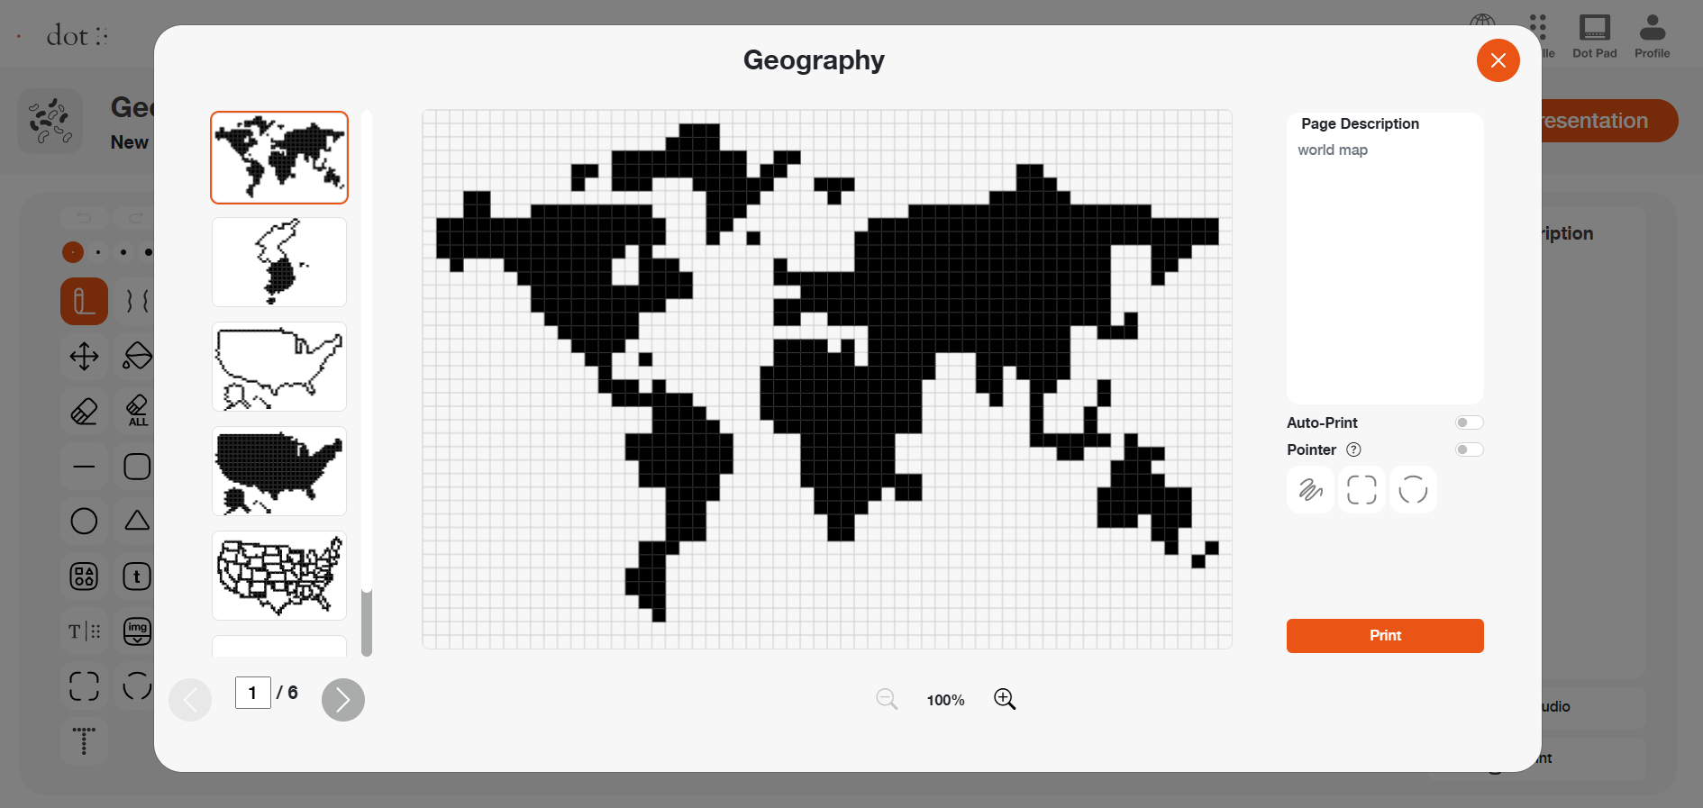

* Presentation Mode offers dynamic learning experience by utilizing Dot Pad and digital tactile graphics in classroom settings.
* Select the Presentation Mode button located in the upper right corner of the Dot Canvas Web screen.
* (1. Auto Print) When DotPad is connected to Dot Canvas Web, users can utilize the auto print feature.
* With the auto print feature enabled, every time users specify an area using the presentation mode pointer, the selected area will automatically be displayed on the DotPad.
* (2. Pointer) Highlight a specific area on the current canvas page using the three types of pointers, and the selected area will be displayed on DotPad.
* (3. Zoom In & Our) To zoom in on the screen, click the magnifying glass icon located at the bottom of the pop-up window. The display can be magnified up to 400% (4x).  
  Use the scroll bars on the right and bottom of the screen to navigate the enlarged area as needed.

1. Multi-Page Management Bar

* This is located on the left side of the canvas. Users can select to show/ hide grid, arrange the order of the pages, delete pages, and add pages.

*※ Grid: Users can choose to show the grid on the drawing area using the grid on/off button.*

* Ctrl key + Up/Down Arrow keys: User can rearrange the order of the pages.

1. Canvas

* The Canvas is a white drawing screen that takes up the biggest part on the screen.
* Users can create new content using the drawing/editing tool or open an existing content from the drive.

1. Page Description

* It is located on the right side of the canvas.
* Users can add descriptions to the images they are creating.
* Descriptions are automatically converted into braille and are displayed correctly only if the input language matches the braille language selected in the Dot Canvas settings.

1. Add Voice

* Users can insert an MP3 file into a specific page. When the file is opened in Dot Cloud, the audio information will play along with the corresponding page output.

1. Print

* It is located below Page Description.
* Once the user clicks [Print], the image on the canvas and the accompanying description will be printed on the Dot Pad.

#### Dot Cloud

Users can save their created content onto the Dot Drive or share it with other people. Users can also print various tactile graphics onto the Dot Pad that are saved on the Public Drive.

Dot Drive is separated into a Personal Drive and the Public Drive. The Personal Drive is the default selected drive when the user first clicks on [Dot Drive]. The Dot Drive screen layout is as follows:

1. Personal Drive ([User’s Name]’s Drive)

* Files saved or folders created on Dot Canvas will be saved here.
* Folders are displayed first before files.
* Users can open files, share, download, rename, copy, cut, paste, or delete by right clicking the file and then selecting the desired option.
* Click [+] to create a new file, new folder, or upload a file. Users can also right click on the empty space in the drive.
* Users can share the files in their Personal Drive to the Public Drive.

※ *Right click on the file you want to share and click [Share]. If you edit a shared file, the shared file will be edited as well.*

*※ The shared file from the personal drive will show the creator’s icon on the thumbnail.*

1. Public Drive

* Shared folders and files are saved here.
* The shared files can be displayed onto the Dot Pad.
* Users can download the shared files onto the computer or open the file to edit them on Dot Canvas.

1. Search

* Users can locate folders and files.
* If users type in the search box, files or folders with matching names will be listed.

1. Back and Forth Buttons

* If you click the back button, the page will be redirected to the previous directory.
* If you click the forward button, the page will be redirected to the next directory.

1. Gallery View Button

* The default mode of the Dot Drive is gallery view mode.
* The list of folders and files are displayed in the form of a gallery where icons are visible.

1. List View Button

* The files will be displayed in list mode.

### Updating Firmware in Dot Support Page

You can update the firmware of the Dot Pad from the Support page on Dot Canvas Web.

Here is how to update the Dot Pad firmware:

* Go to Dot Canvas Web at [apps-dotincorp.com](https://apps-dotincorp.com/)
* Select the Dot Support tab within Dot Canvas Web.
* Connect the Dot Pad to your PC via the USB C port located on the left side of your Dot Pad. After connecting, turn on the Dot Pad and press the Connect Device button on the Dot Support page.

*※ Ensure the device remains powered on and the cable is securely connected throughout the update process.*

* Connect the Dot Pad by selecting one of the wired port options that appears in the pop-up. If a connection failure notice is displayed, turn the Dot Pad off and on again and try again. After connecting, you can check the device information on the Dot Support page and update it to the latest firmware.
* Select the [Update] button at the bottom of the Dot Pad Firmware Version Information to proceed with the firmware update. The update takes about 3 to 5 minutes depending on the Internet speed.

*※ If the firmware is in the latest version, an "Already the latest version of firmware" notice will be displayed.*